

Building Structures [ARC 2522]
Project 1: Extension of a R.C Structure

Chosen Existing R.C Building:
Jalan Uthant, Kuala Lumpur

Name: HANS HOSEA GONZA
Student ID: 0311772
Lecturer : MS Ann See Peng
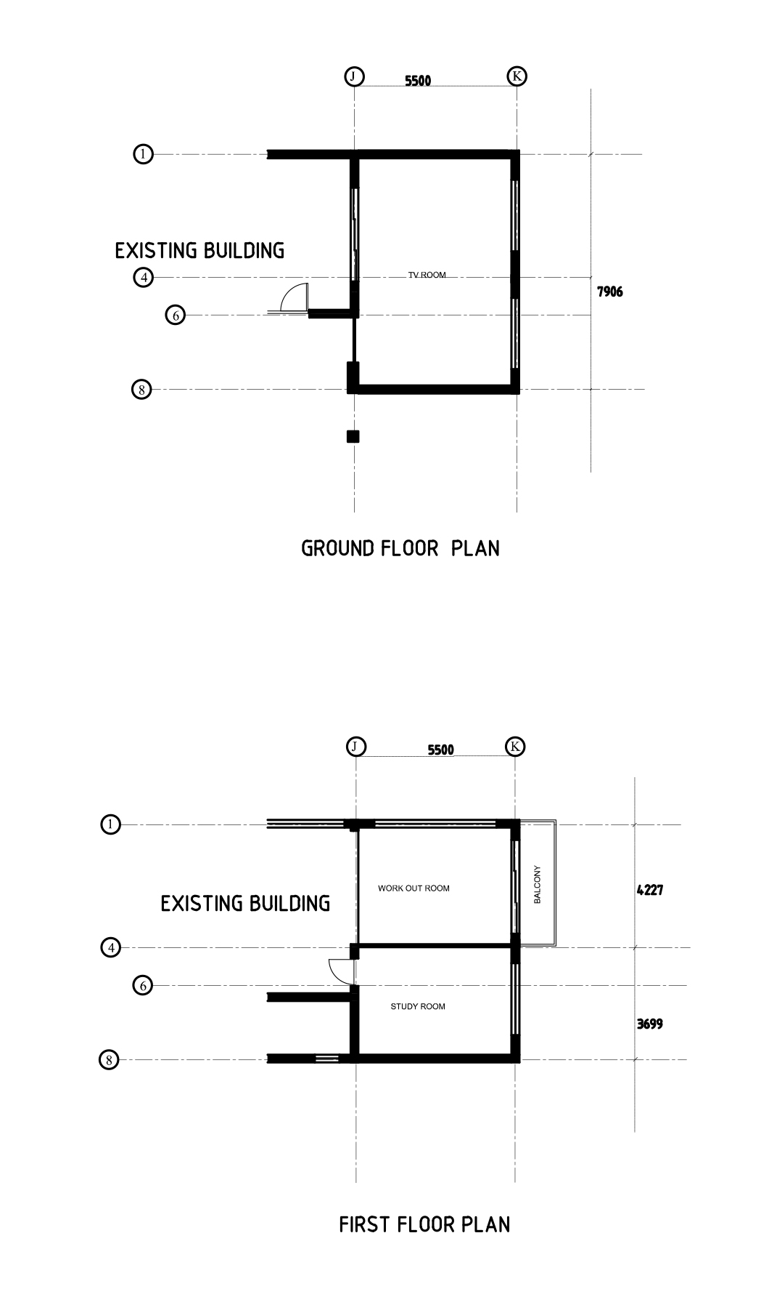PROPOSED EXTENSION

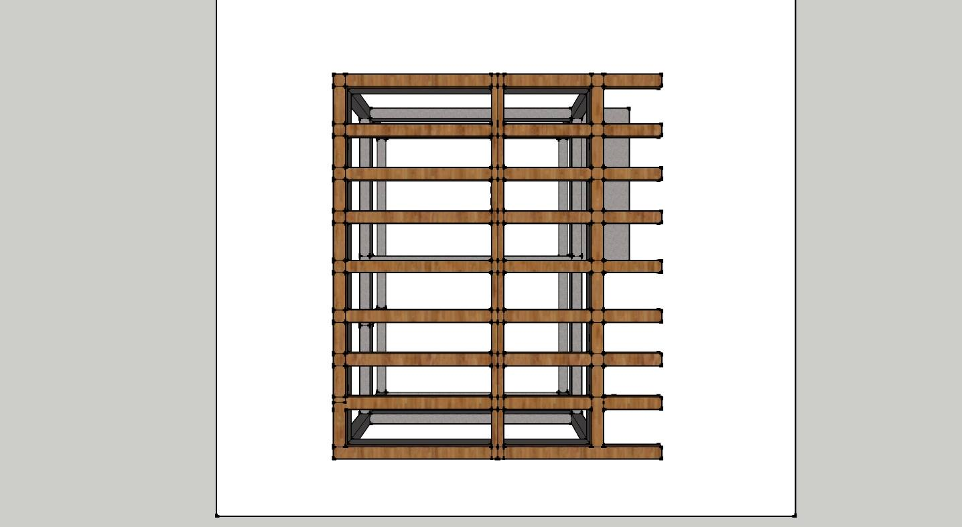
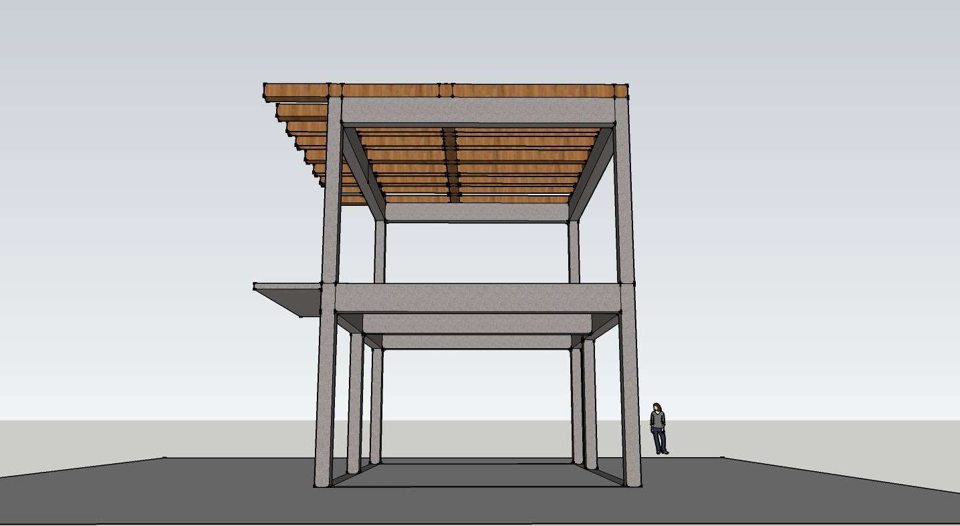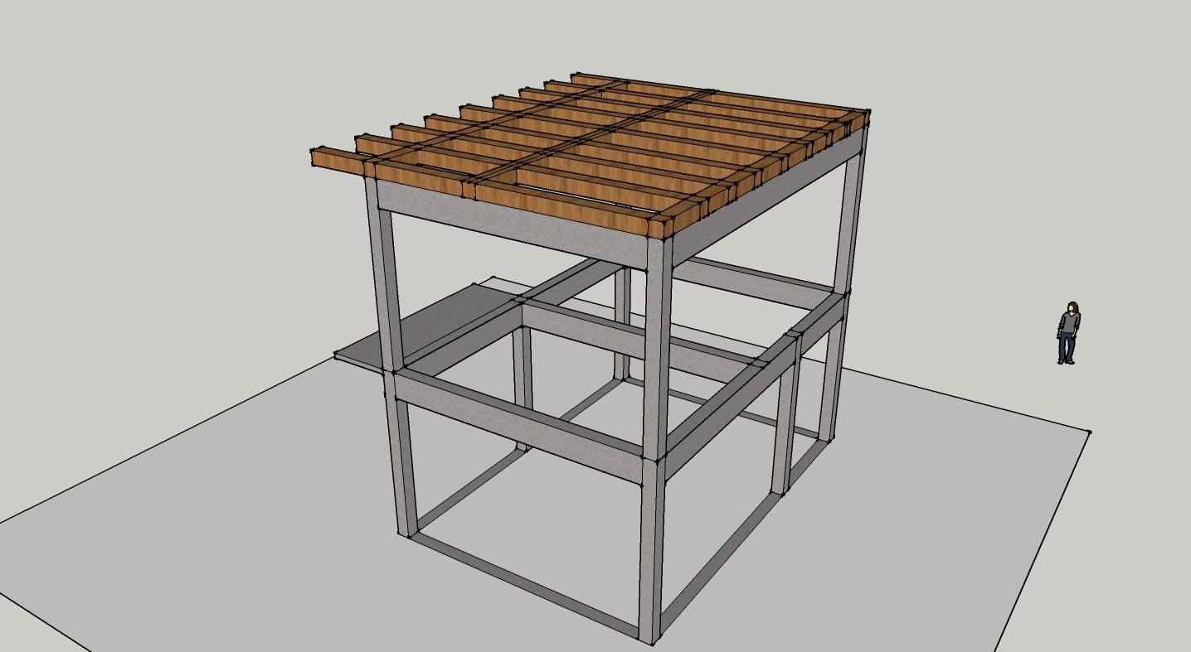
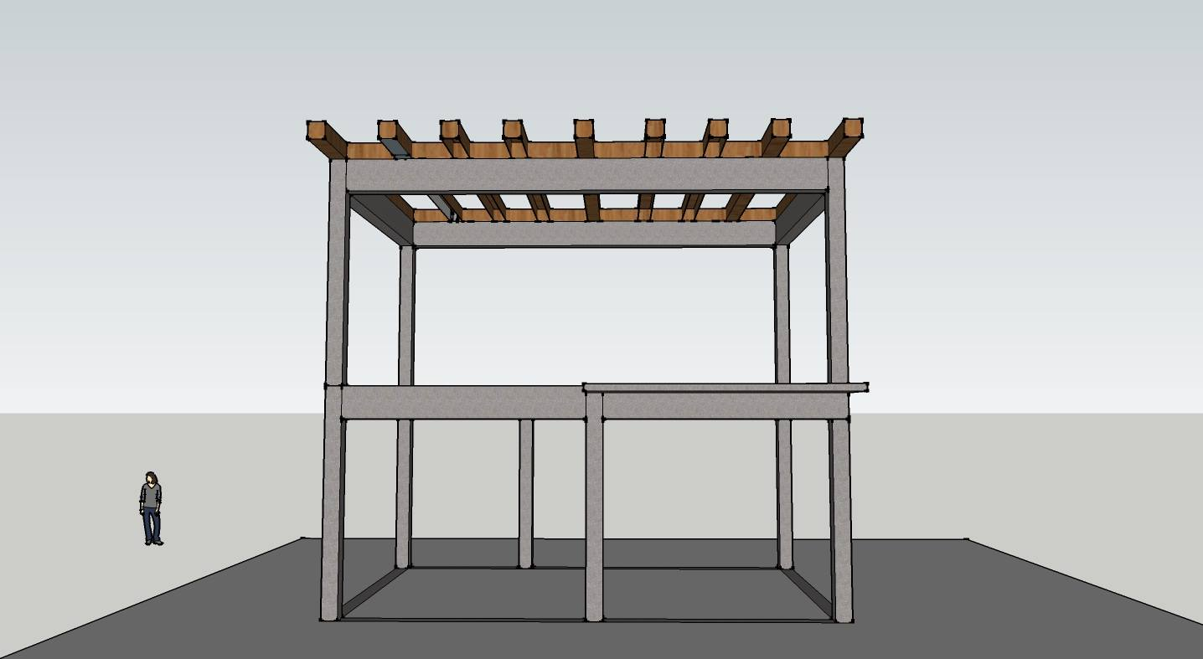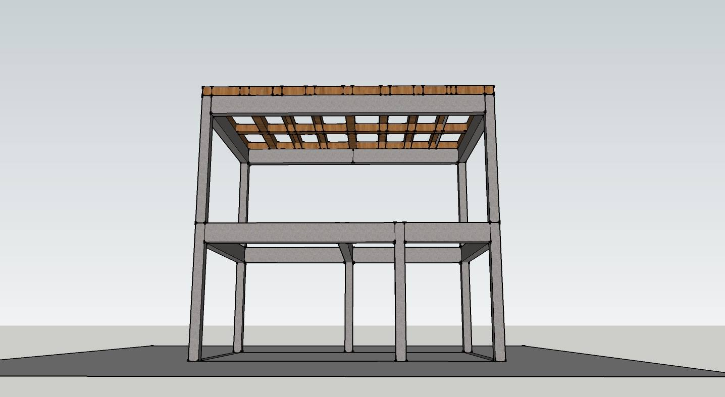

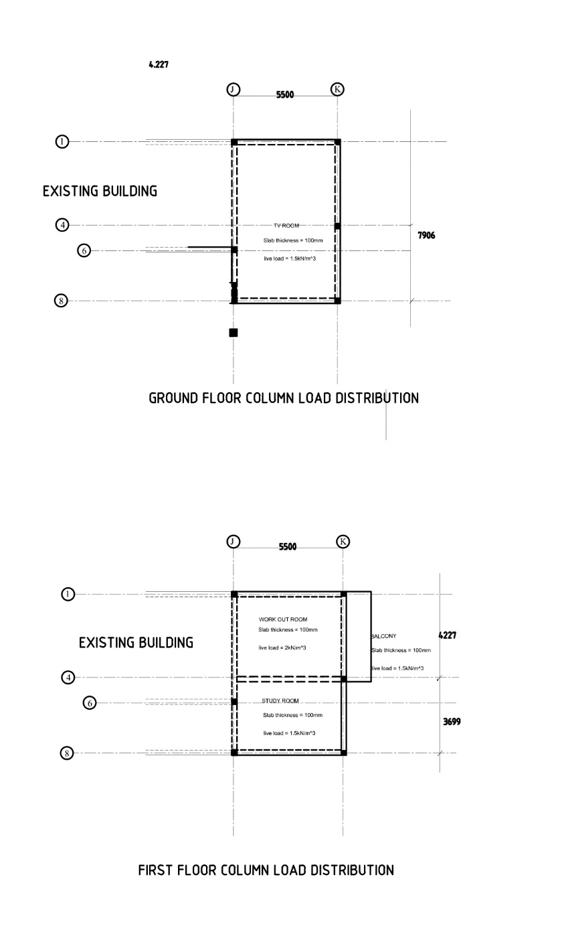
SLAB THICKNESS AND LIVE LOAD

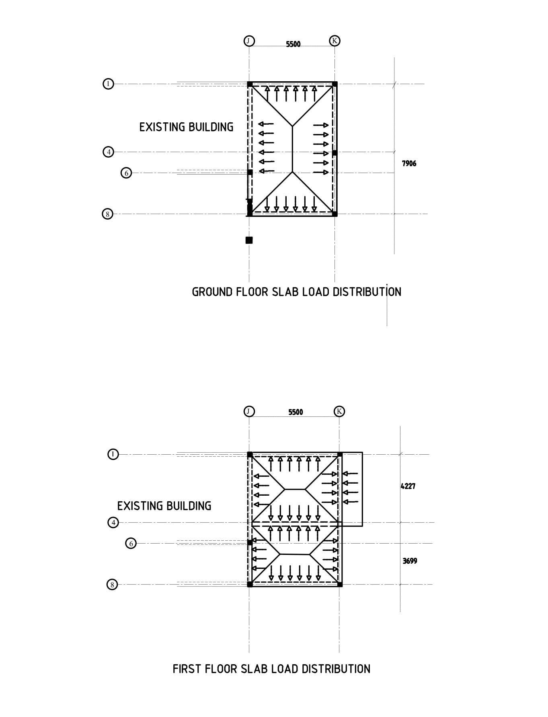ONE WAY AND TWO WAY SLABS
BEAM ANALYSIS CALCULATION

Beam K/4-8
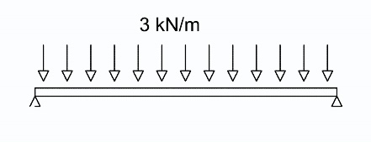
Beam self-weight
=0.25m x0.5m x24kN/m³
=3kN/m

Slab
=ly/lx
=5.5m / 3.6699m =1.4986 (two way slab)
Slab dead load
=0.1m x 24kN/m³
=2.4kN/m³

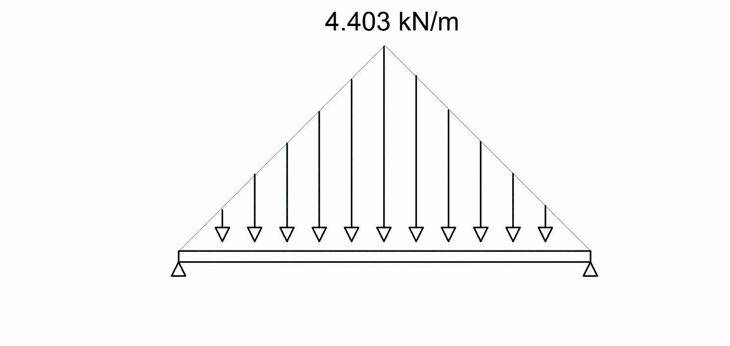Dead load from slab
DL x (lx/2)
=2.4 x (3.6699/2)
=4.40388kN/m
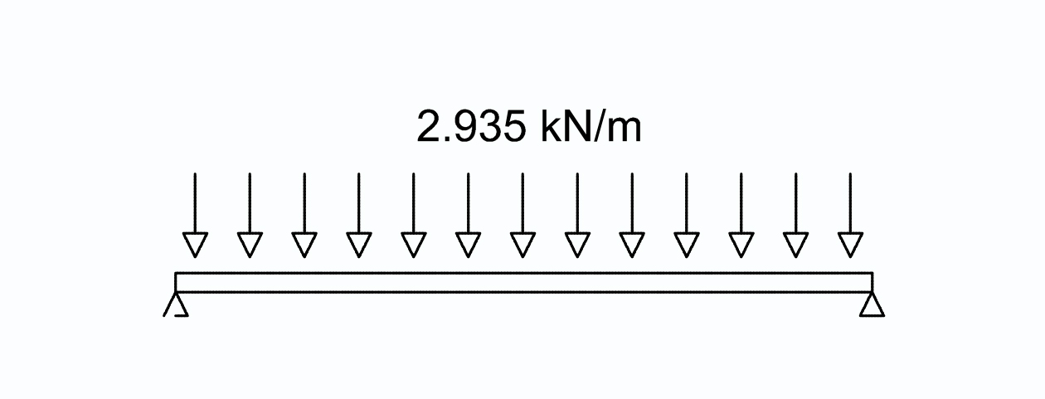

Converting to UDL
4.40388 x (2/3) = 2.935kN/m

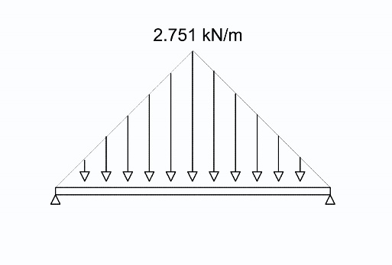
Live load on slab
LL x (Lx/2)
1.5 x (3.669/2) =2.751kNm

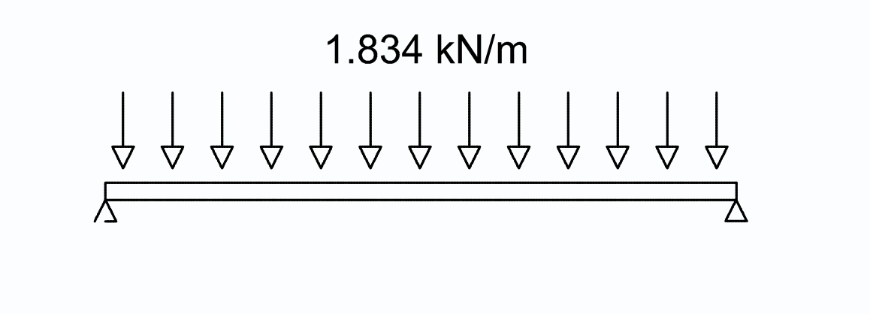Converting to UDL
2.751 x (2/3) =1.834kN/m

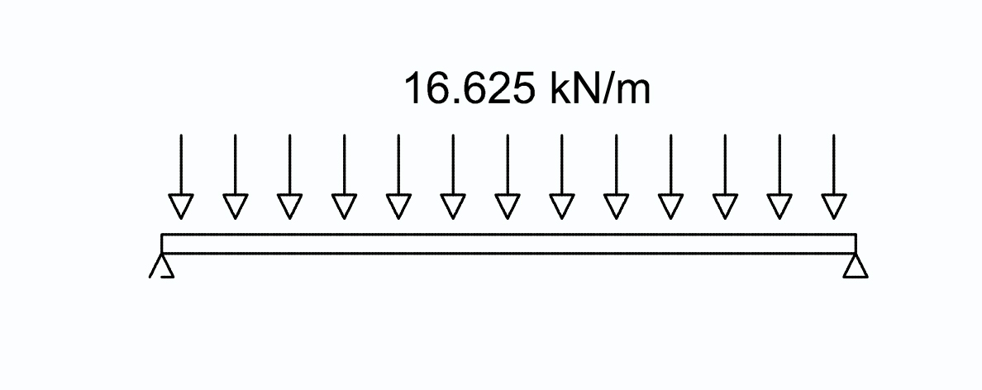Brick wall
=wall height x Thickness x Density
=3.5 x 0.25 x 19
=16.625kN/m
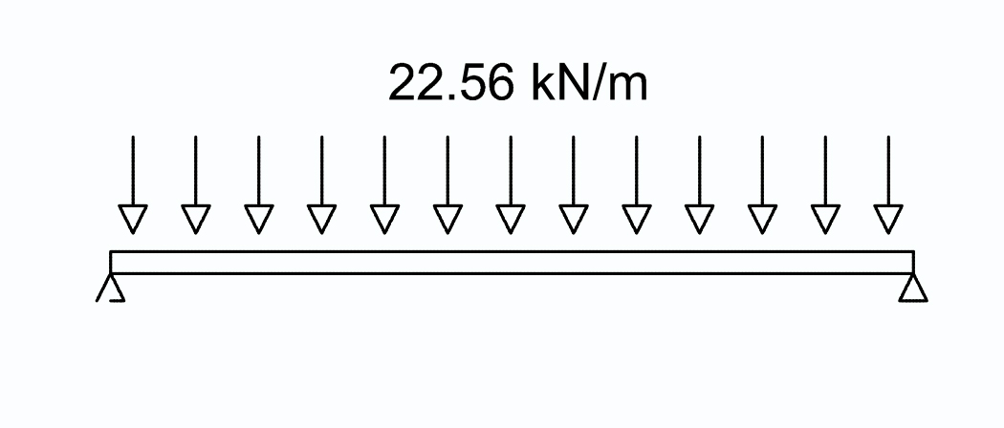
Total dead load
=16.625+ 3+ 2.935
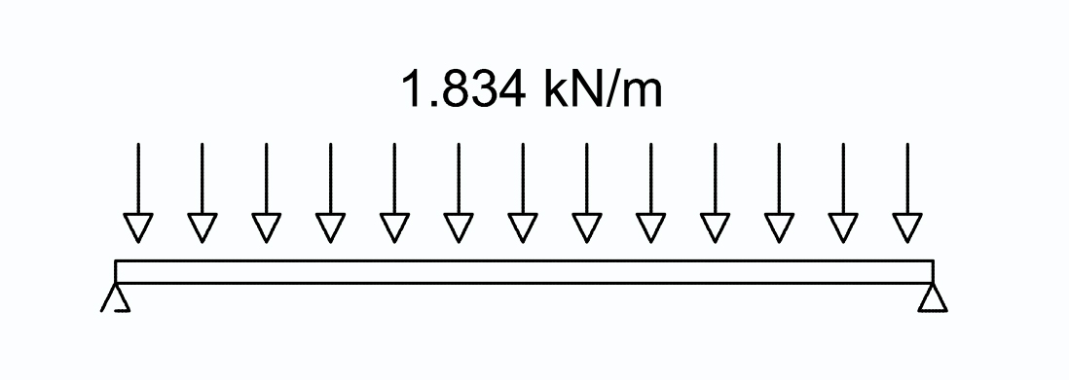 =22.56kN/m

Total live load
=1.834kn/m

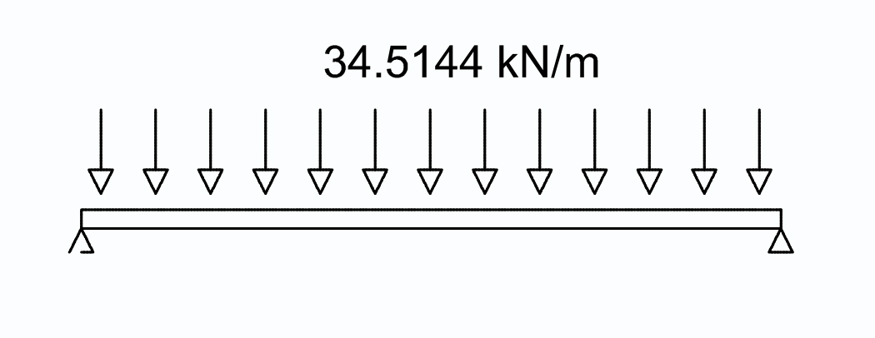Ultimate load= 1.4(DL) + 1.6(LL)
= (1.4x22.56) + (1.6x1.834)
=34.5144kN/m

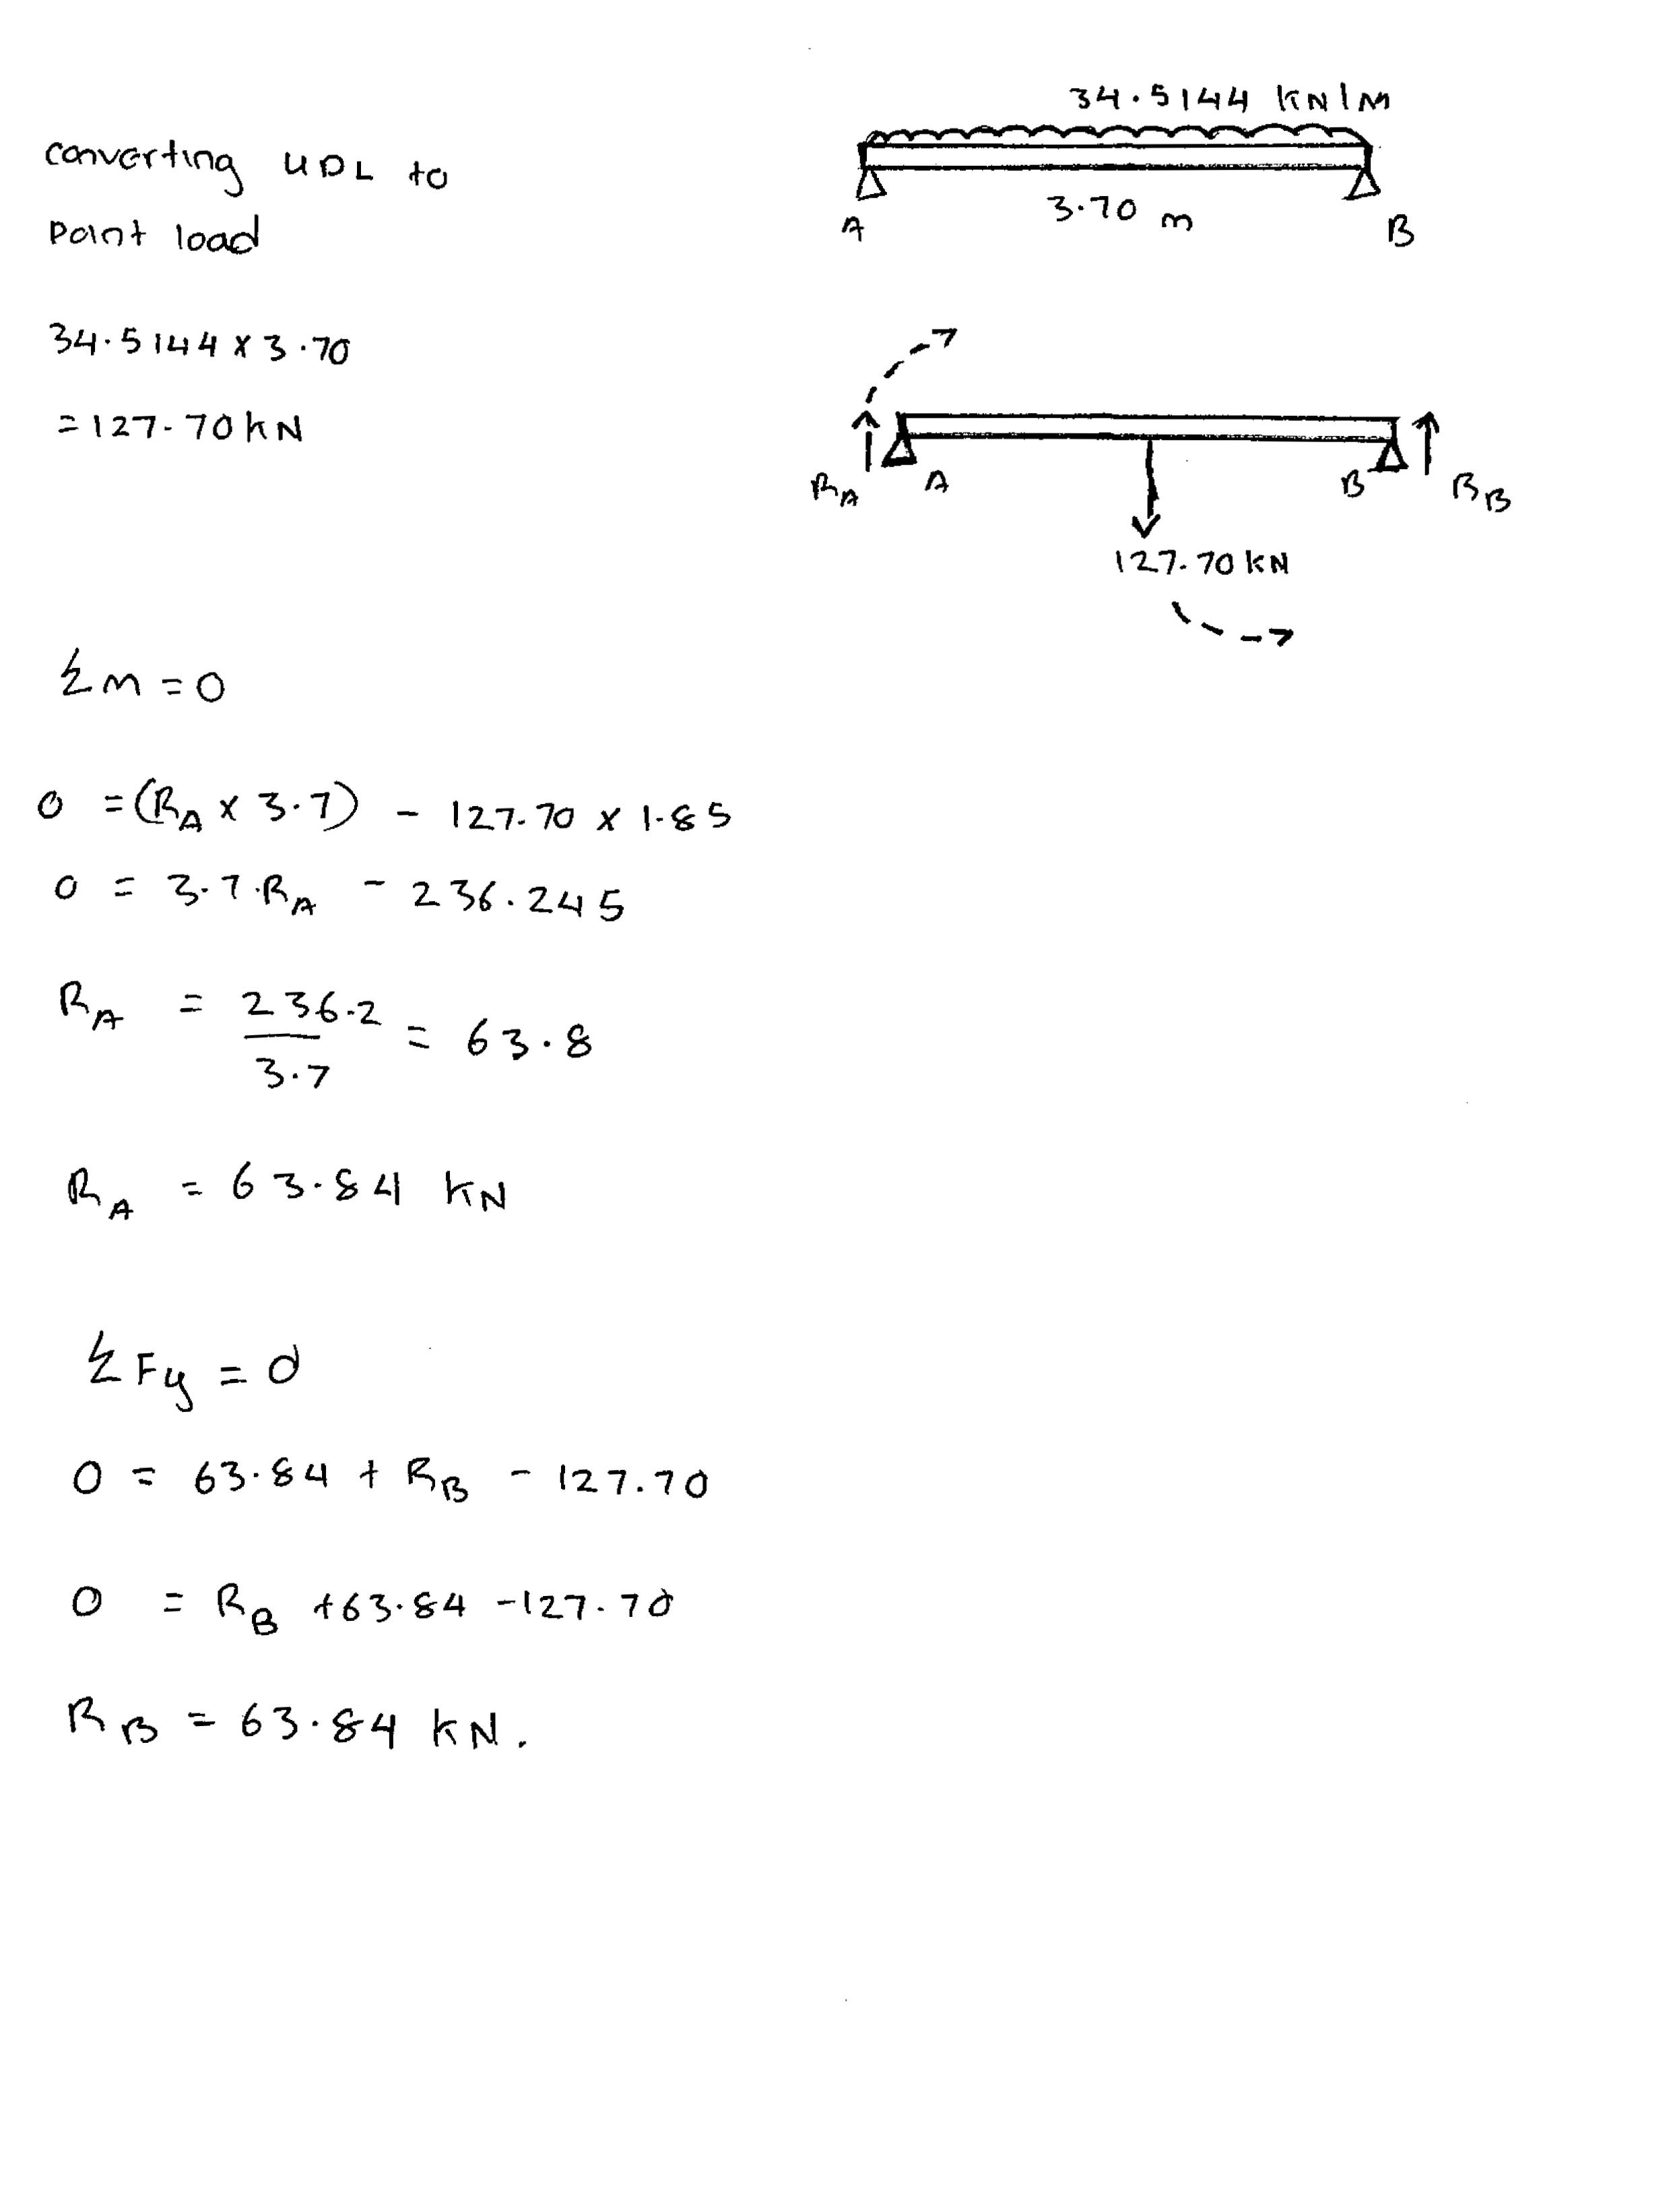REACTION FORCES
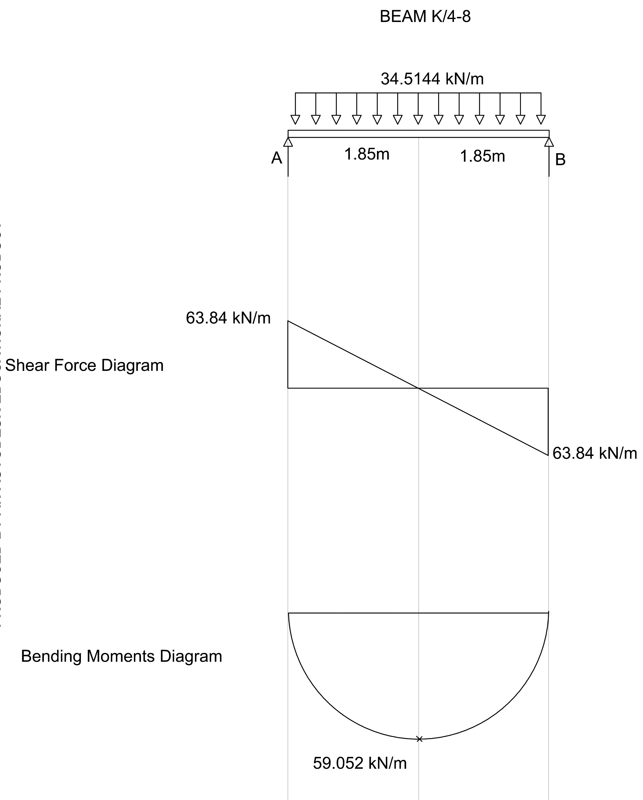SHEAR FORCE AND BENDING MOMENTS DIAGRAMS

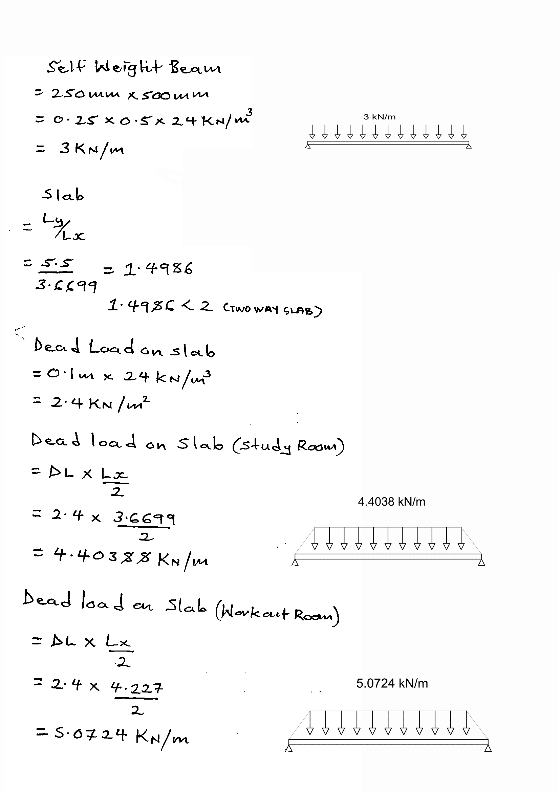BEAM 4/ J-K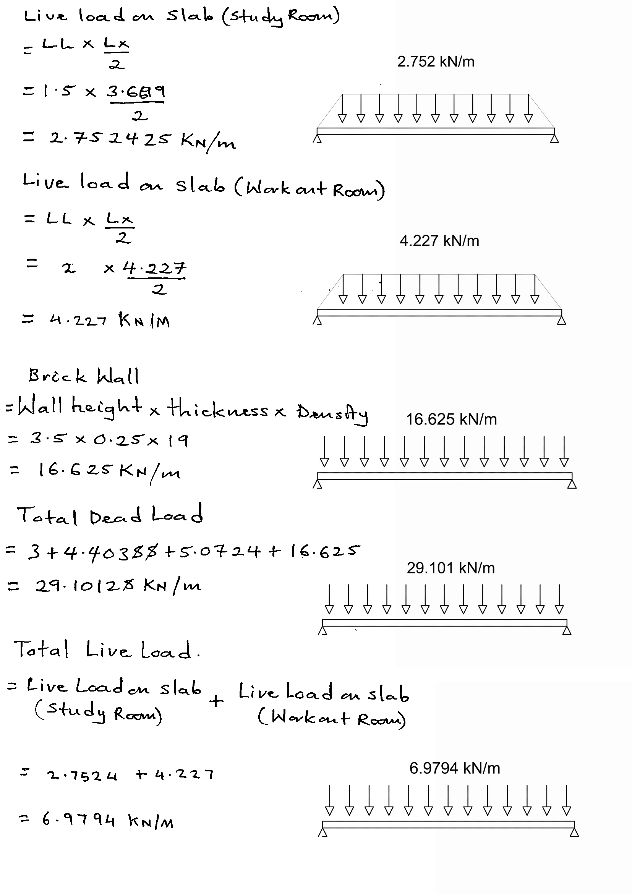
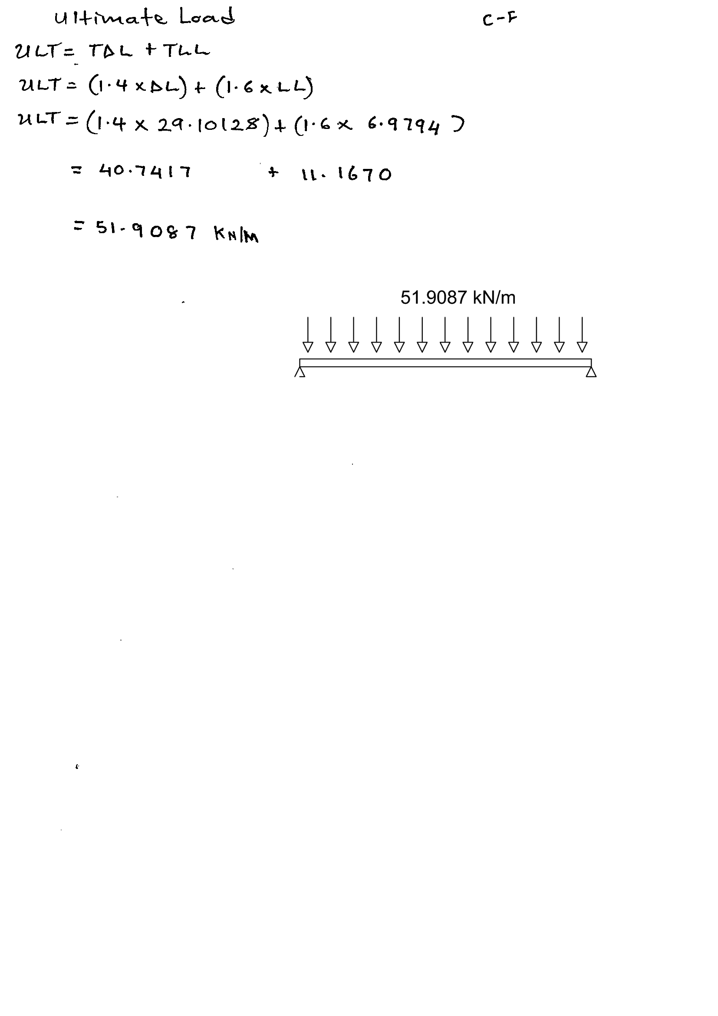
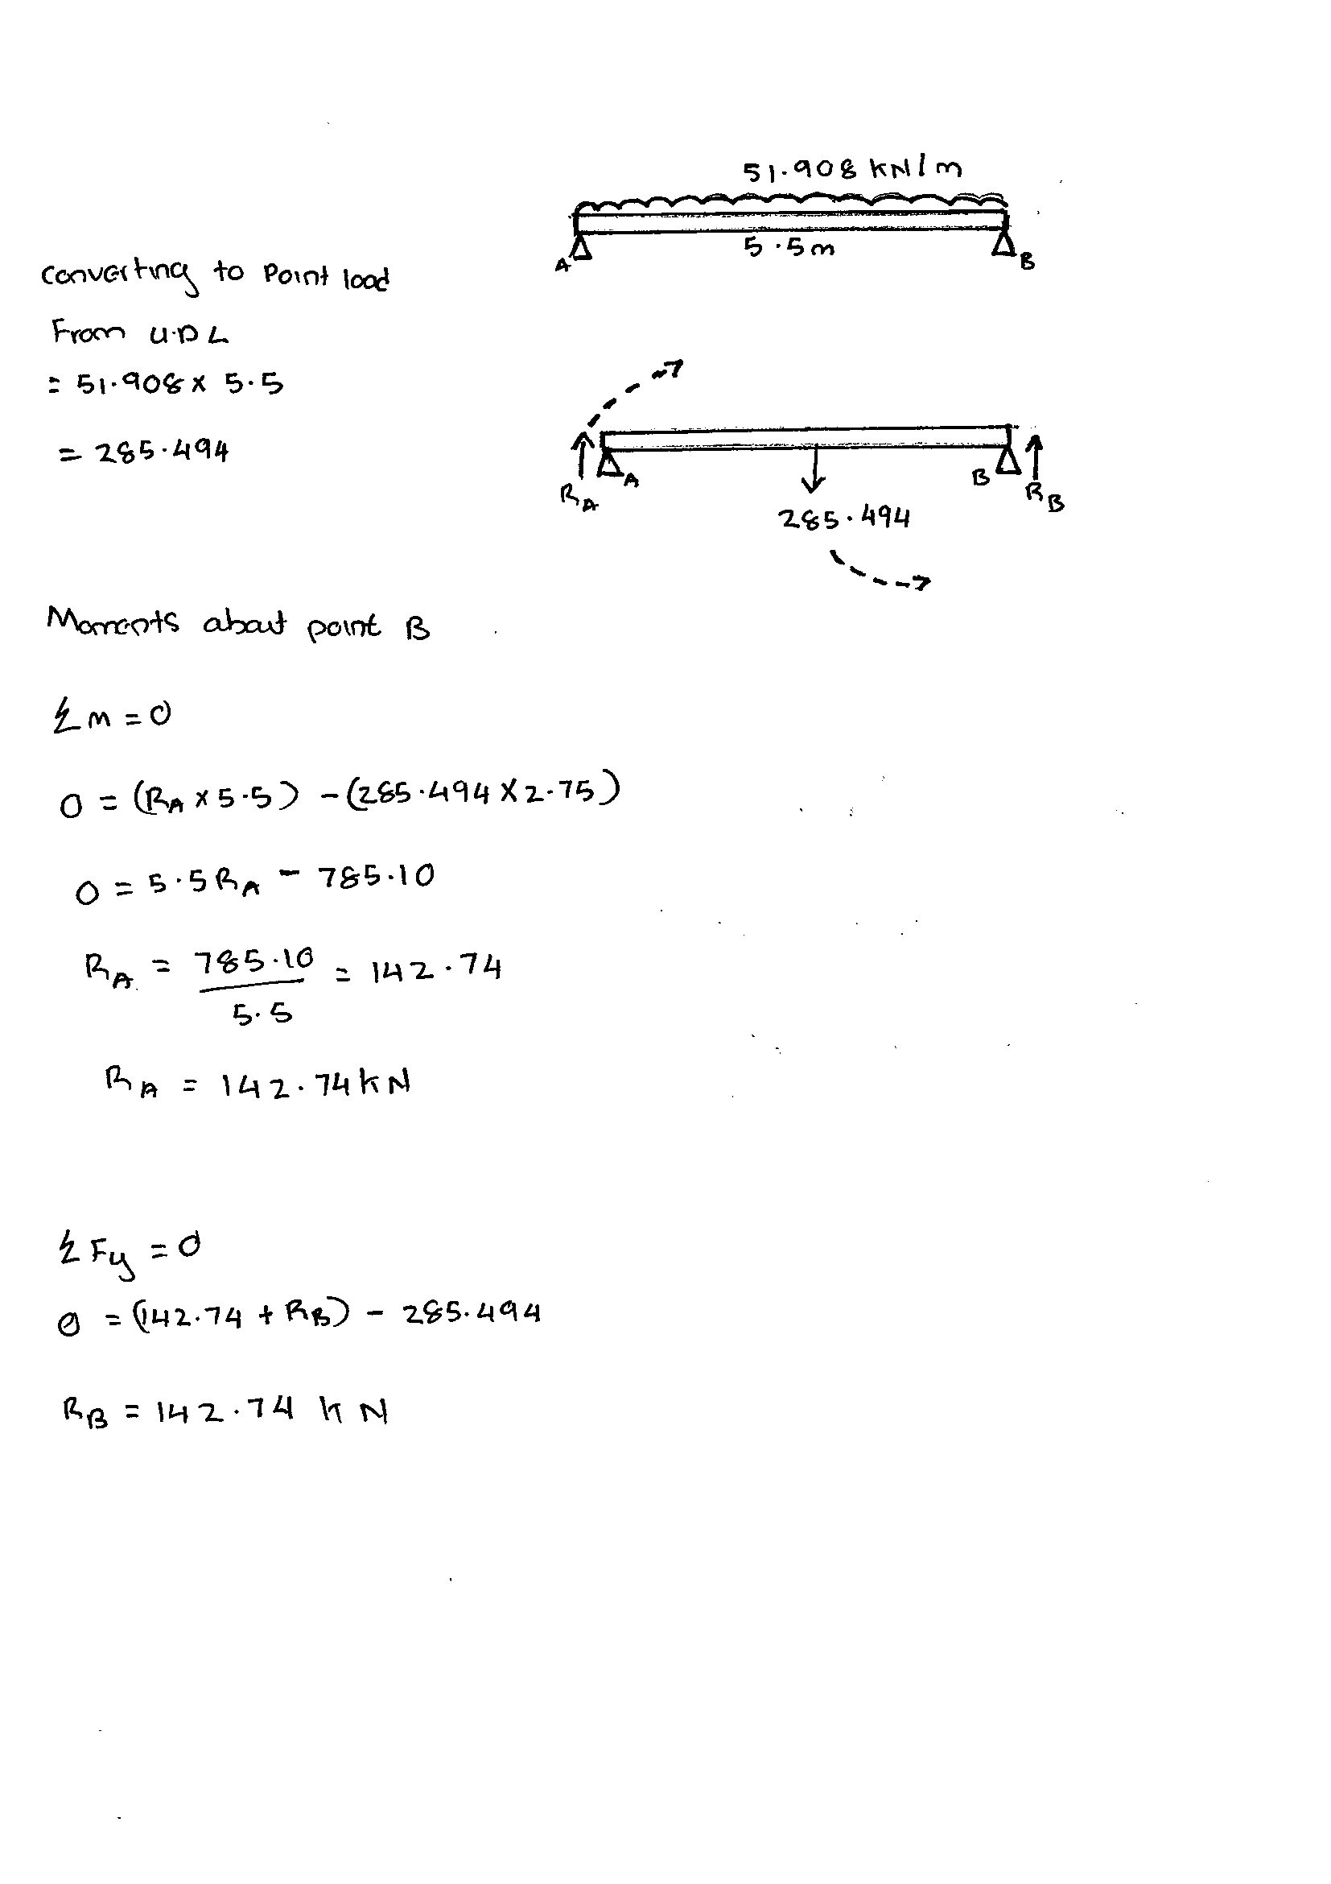REACTION FORCES ON BEAM 4/ J-K

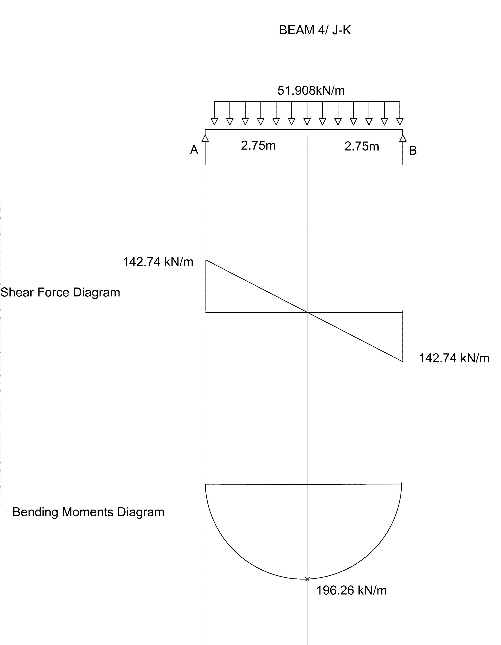SHEAR FORCE AND BENDING MMENTS DIAGRAM
BEAM K/ 1-4

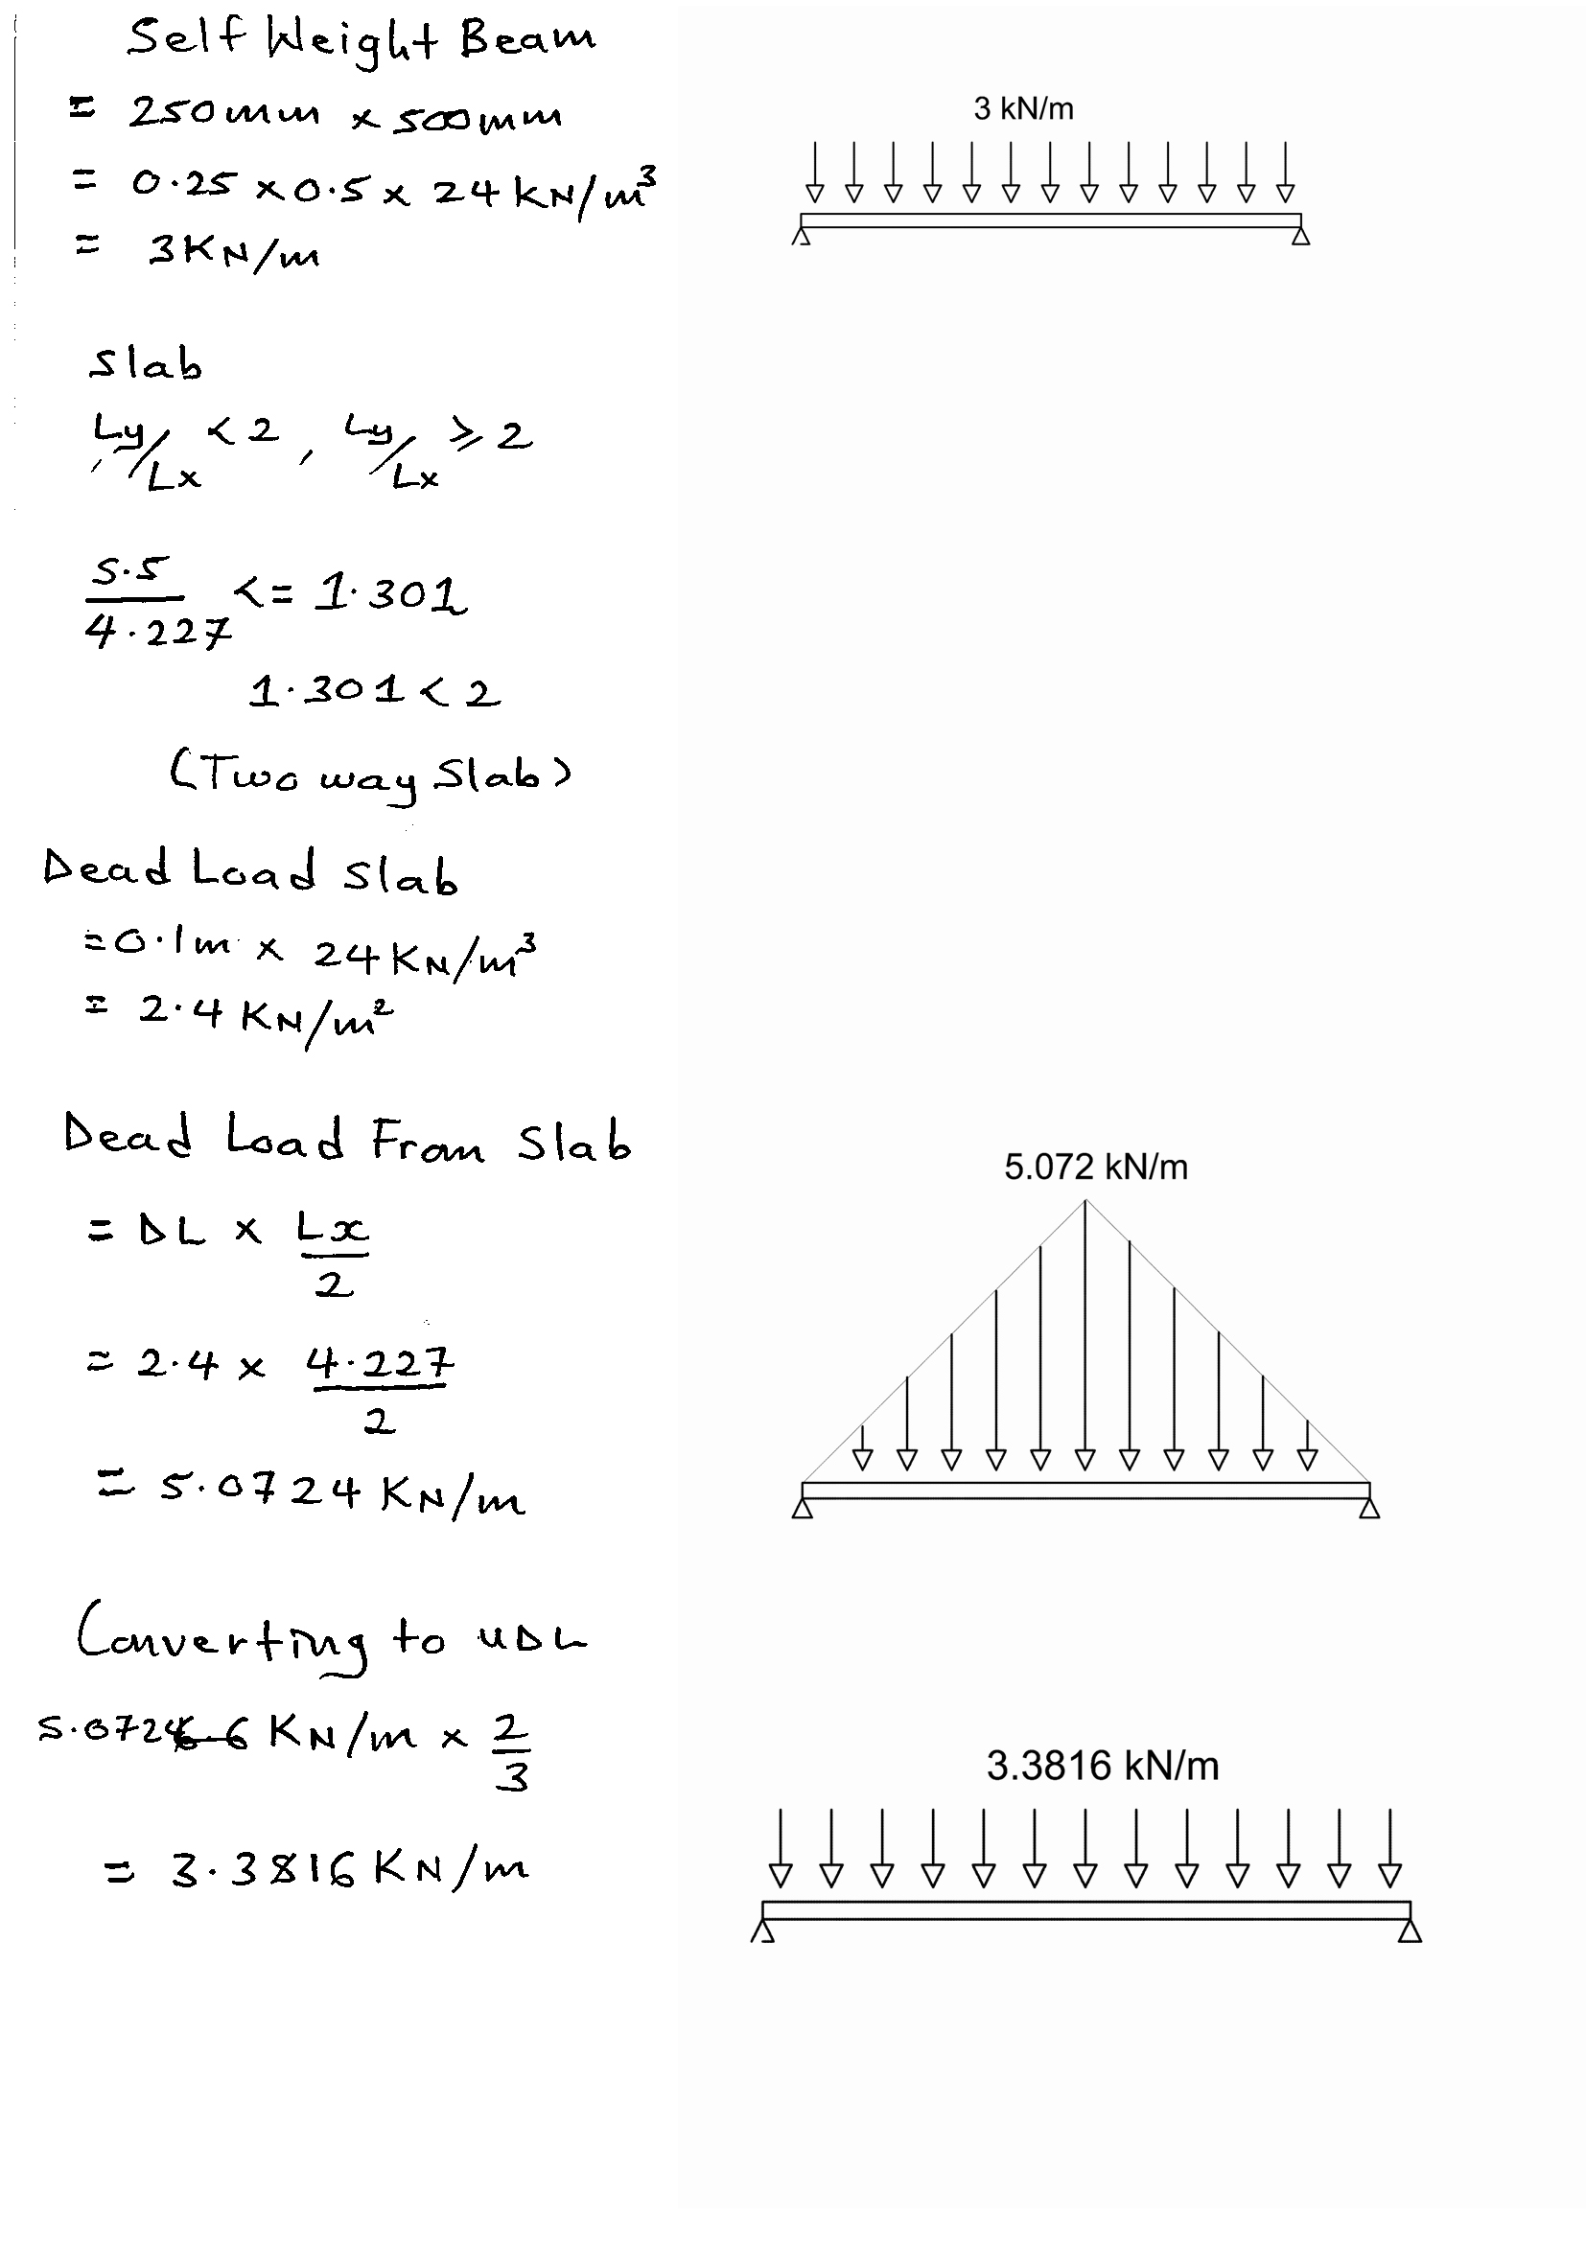

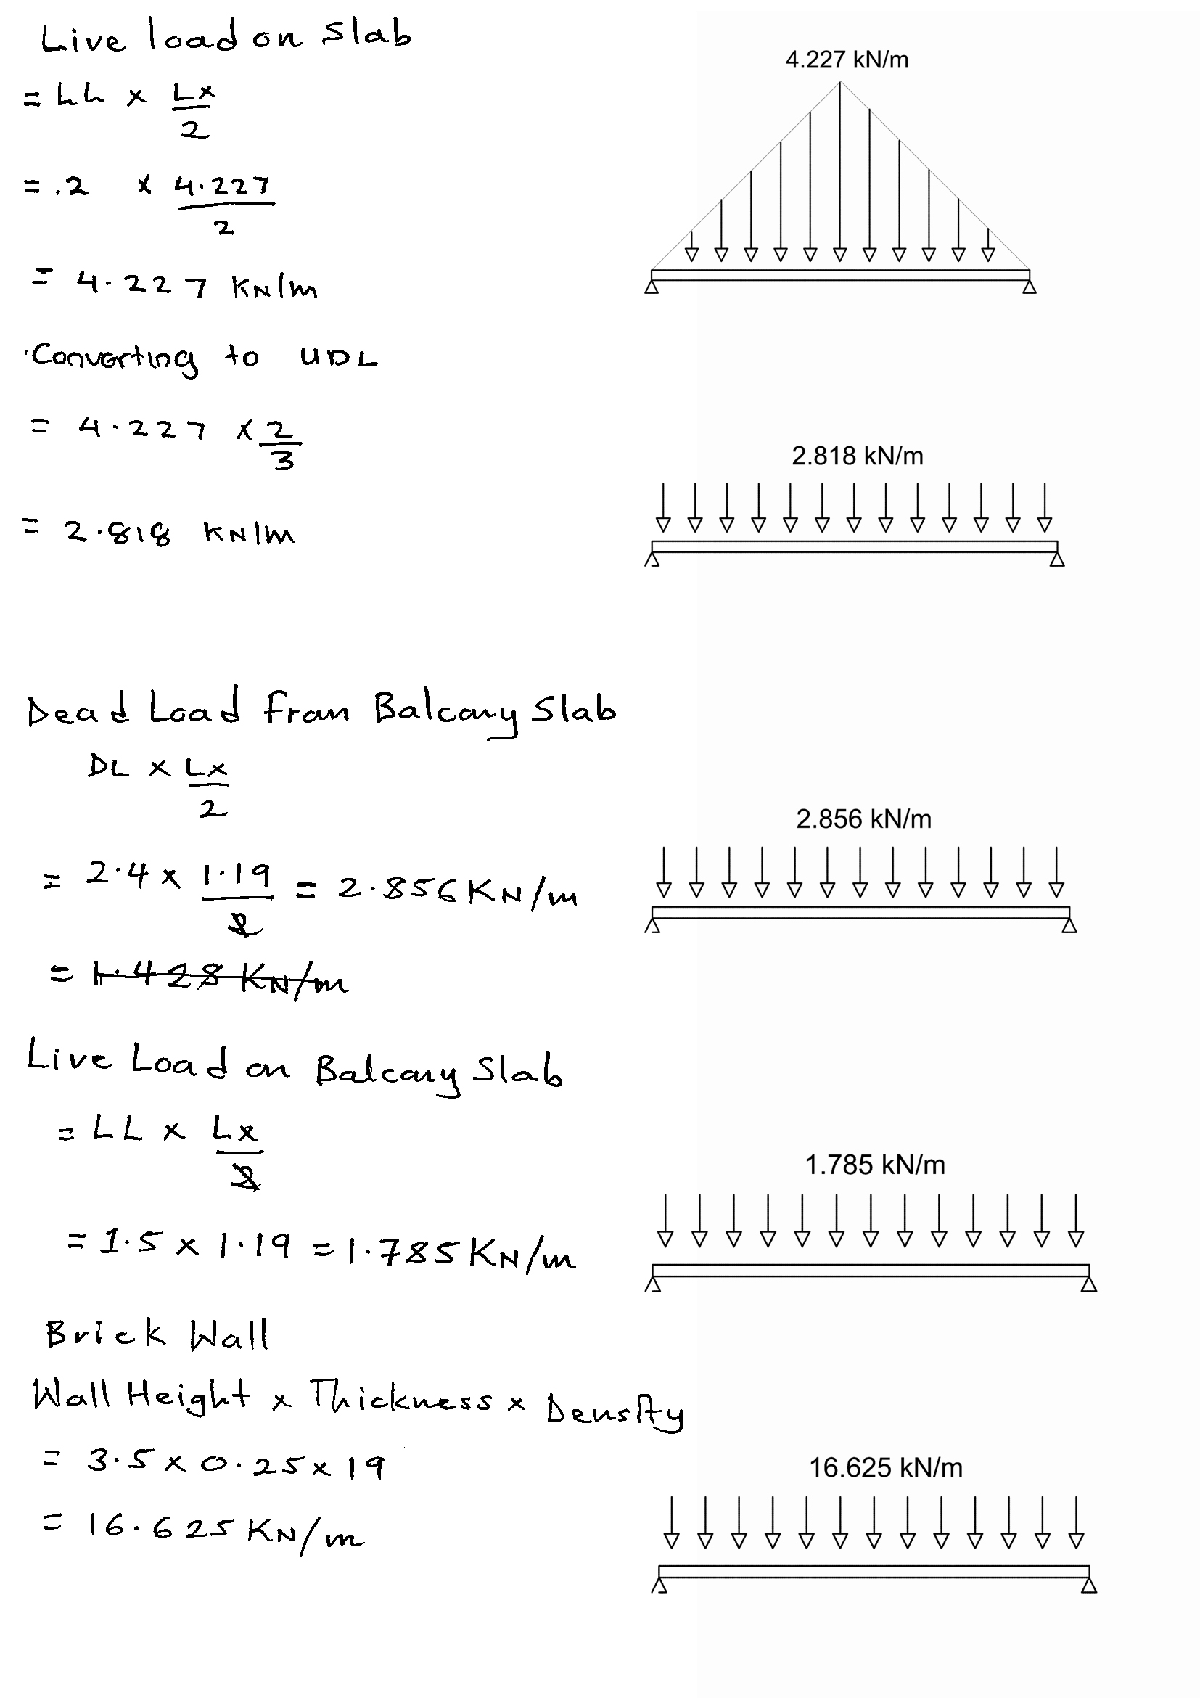

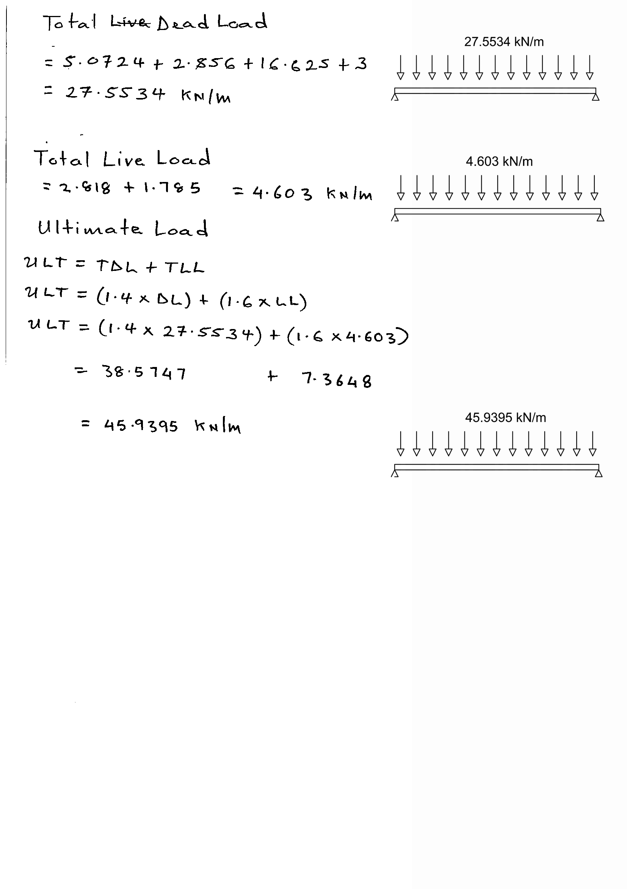

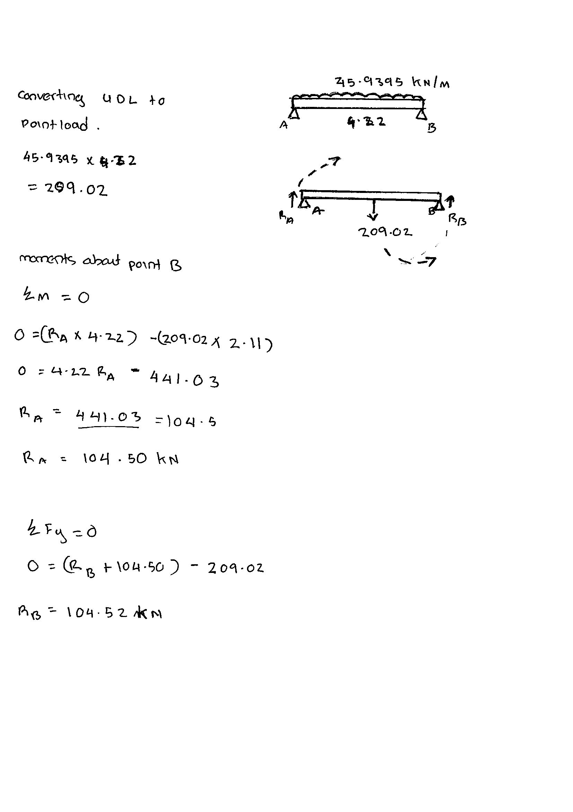REACTION FORCES

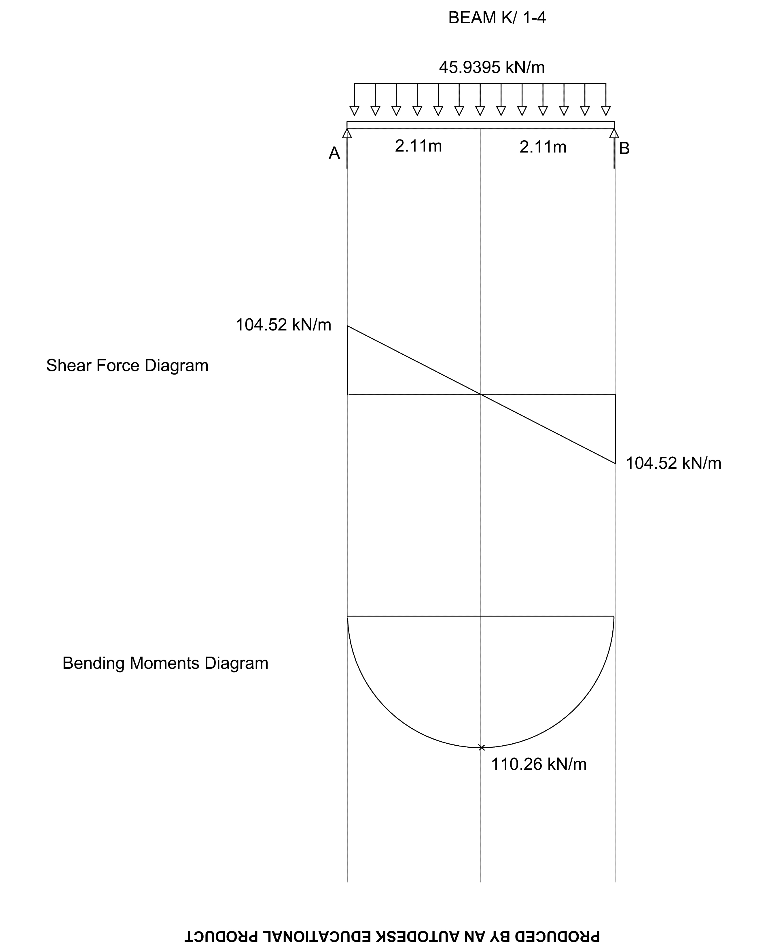SHEAR FORCE AND BENDING MOMENTS DIAGRAM

BEAM 1/ J-K
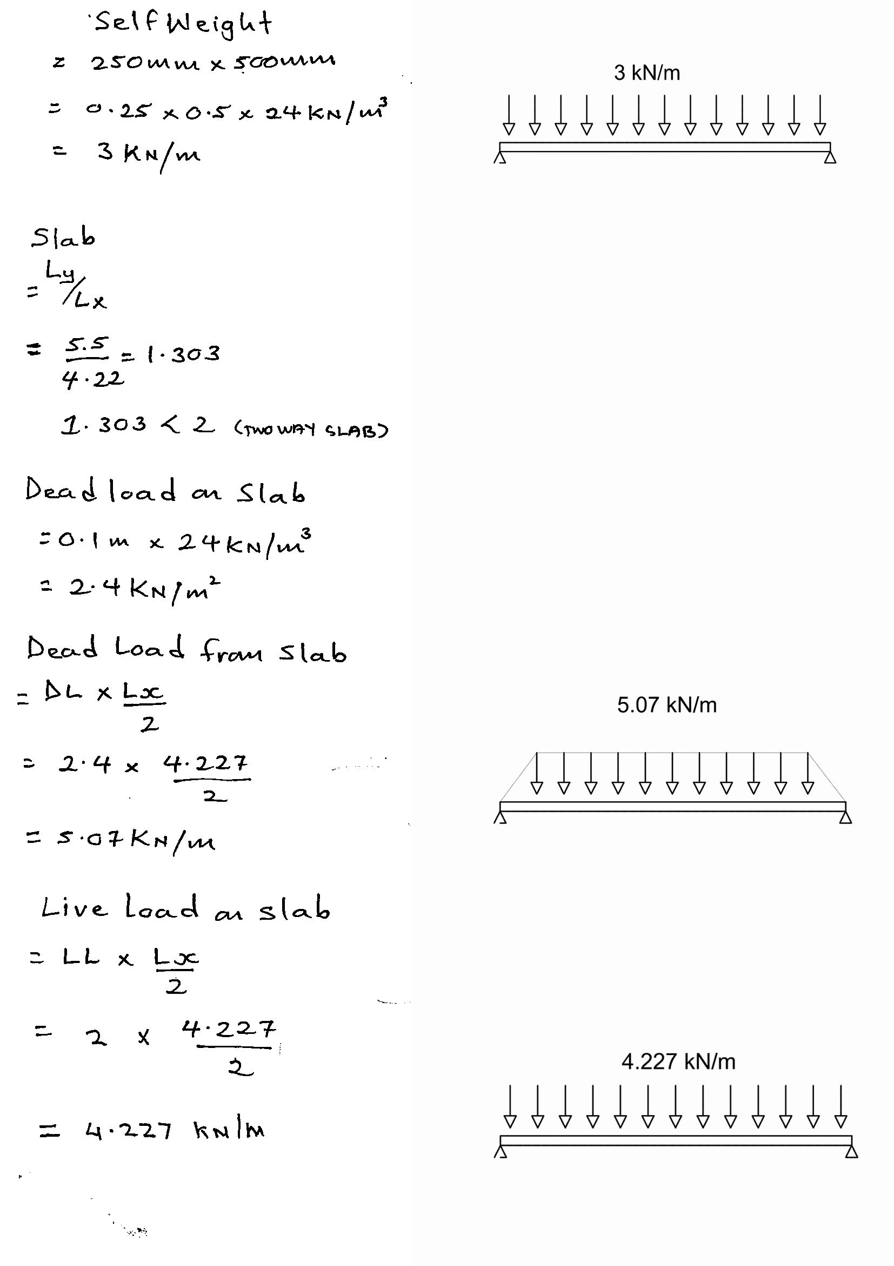

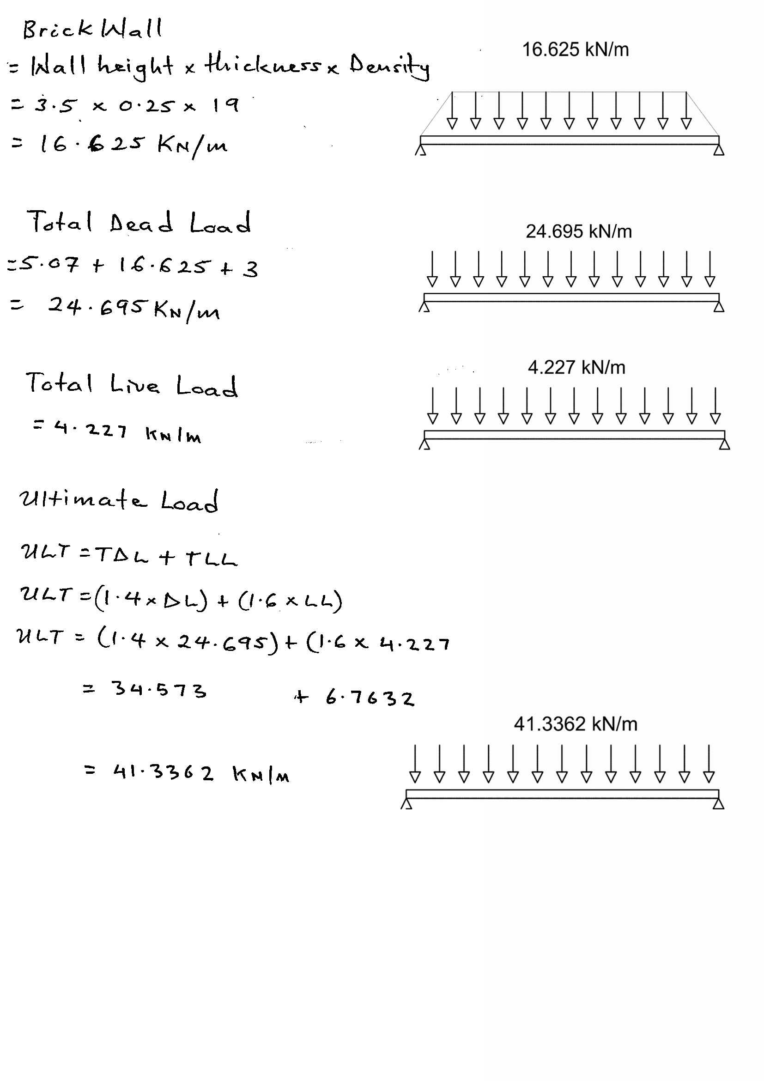

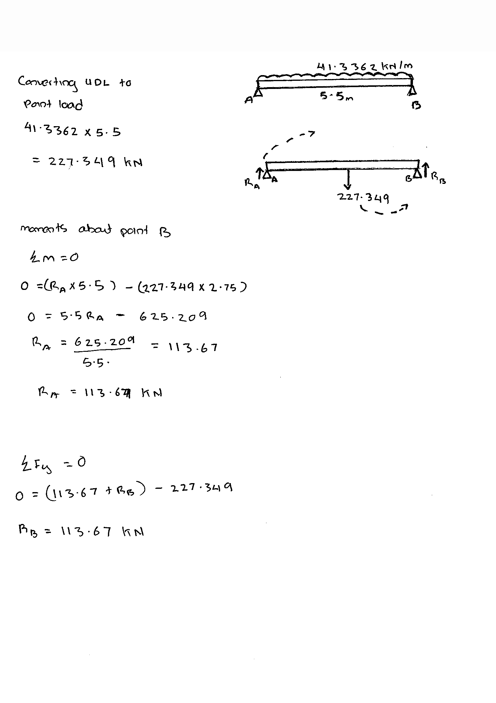REACTION FORCES

SHEAR FORCE AND BENDING MOMENTS DIAGRAM
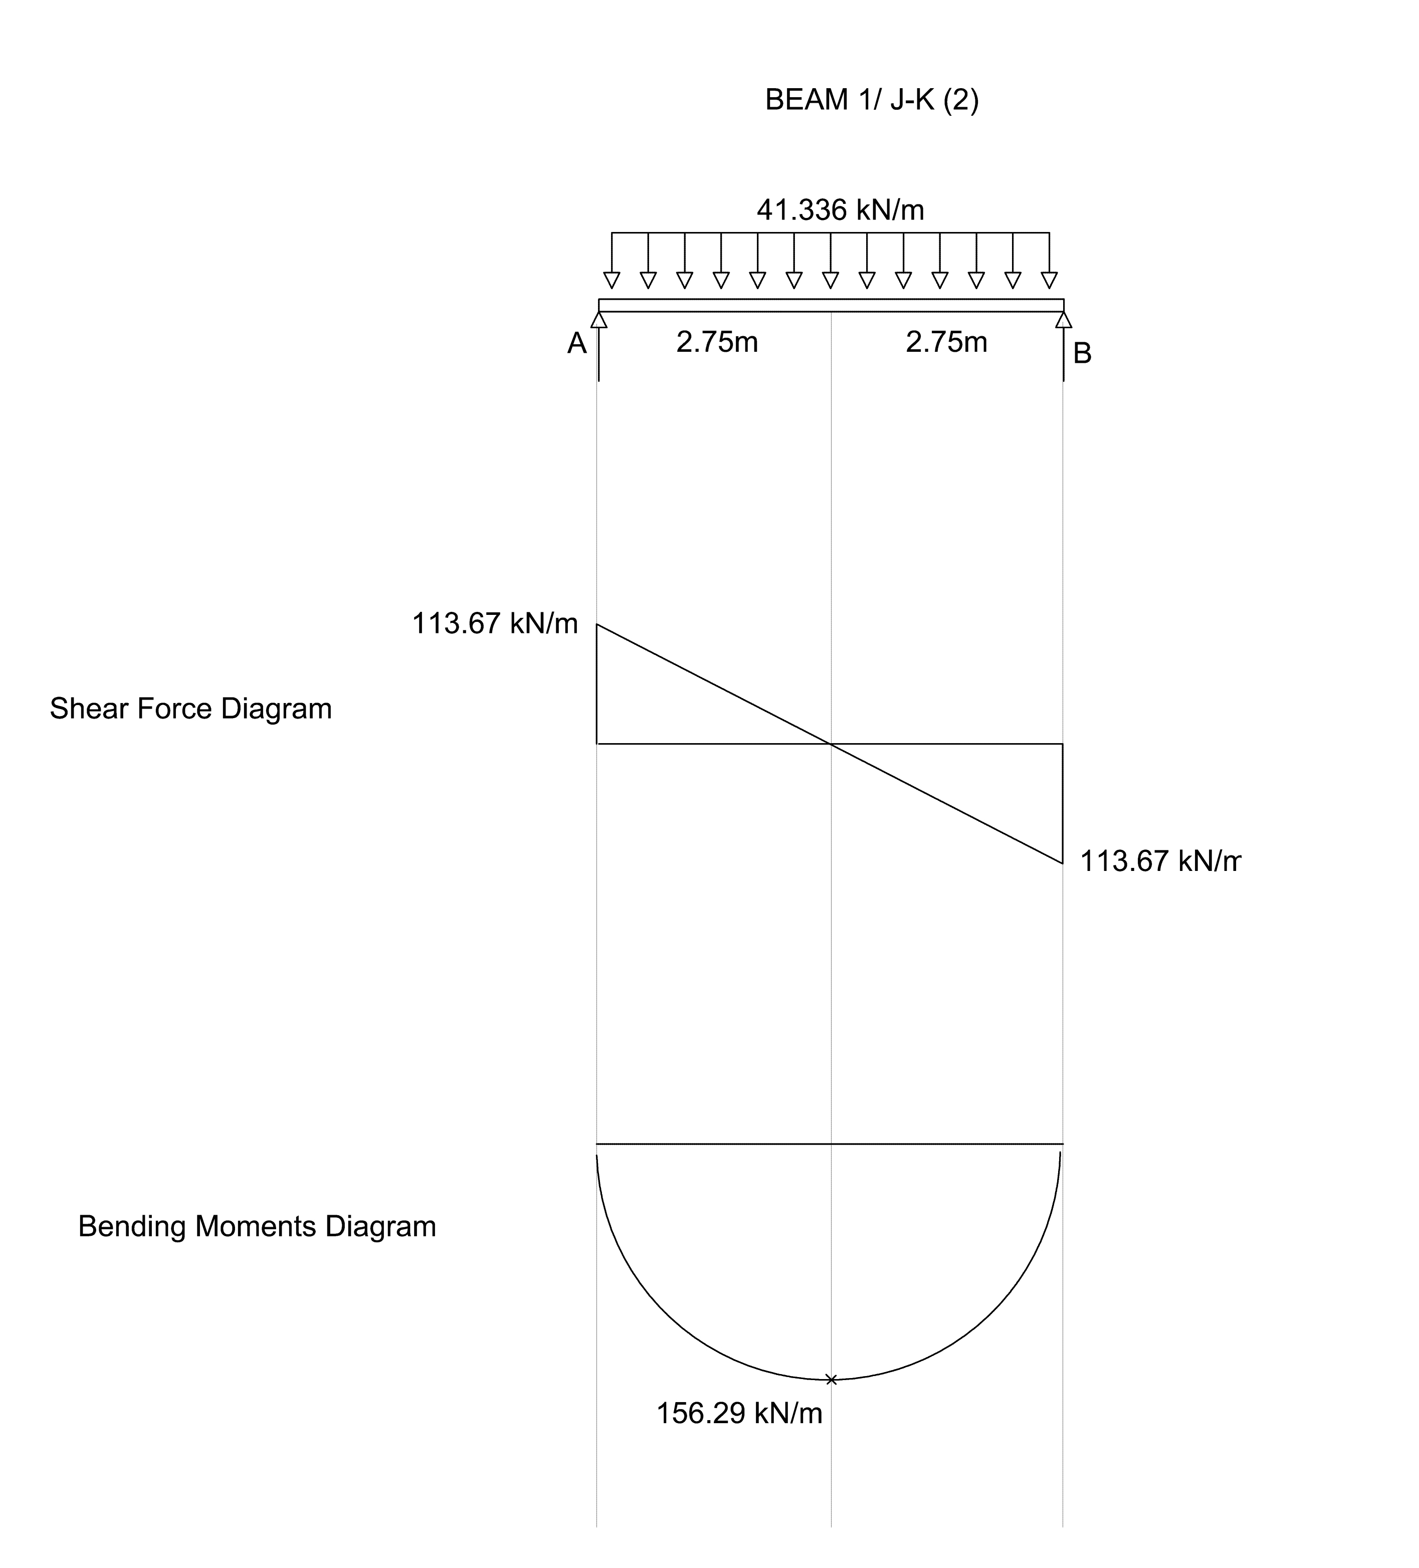
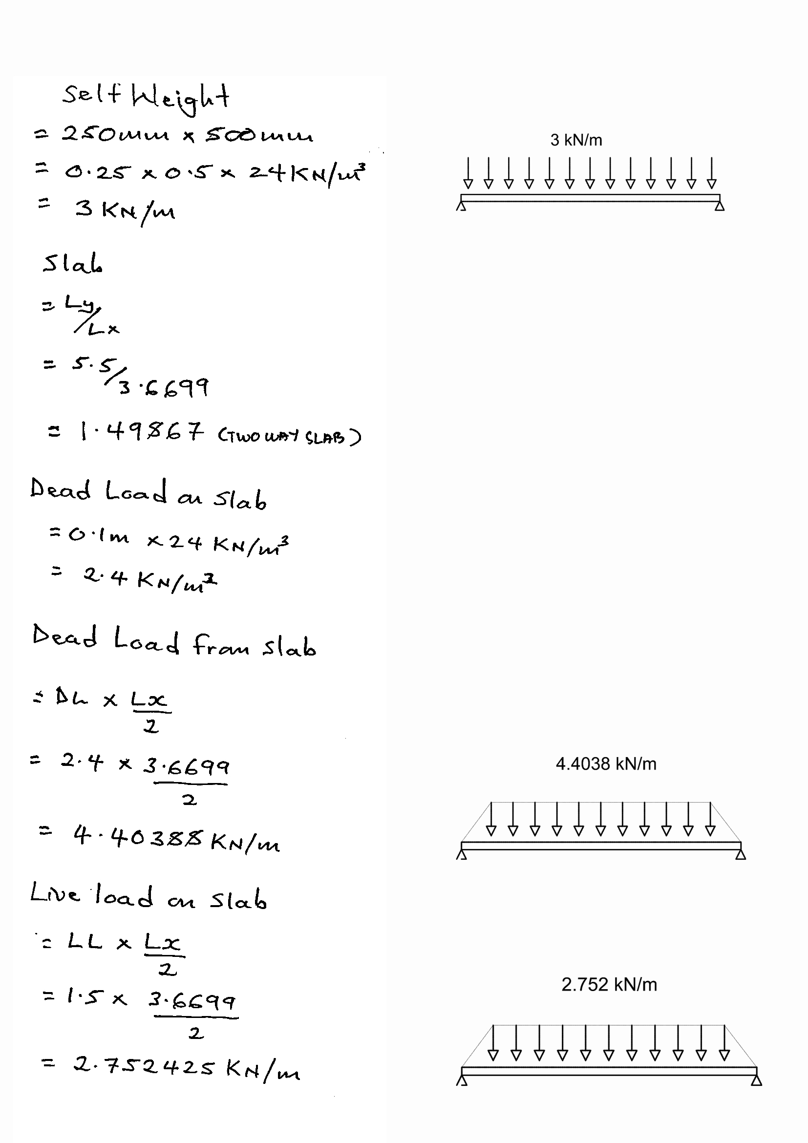BEAM 8/ J-K

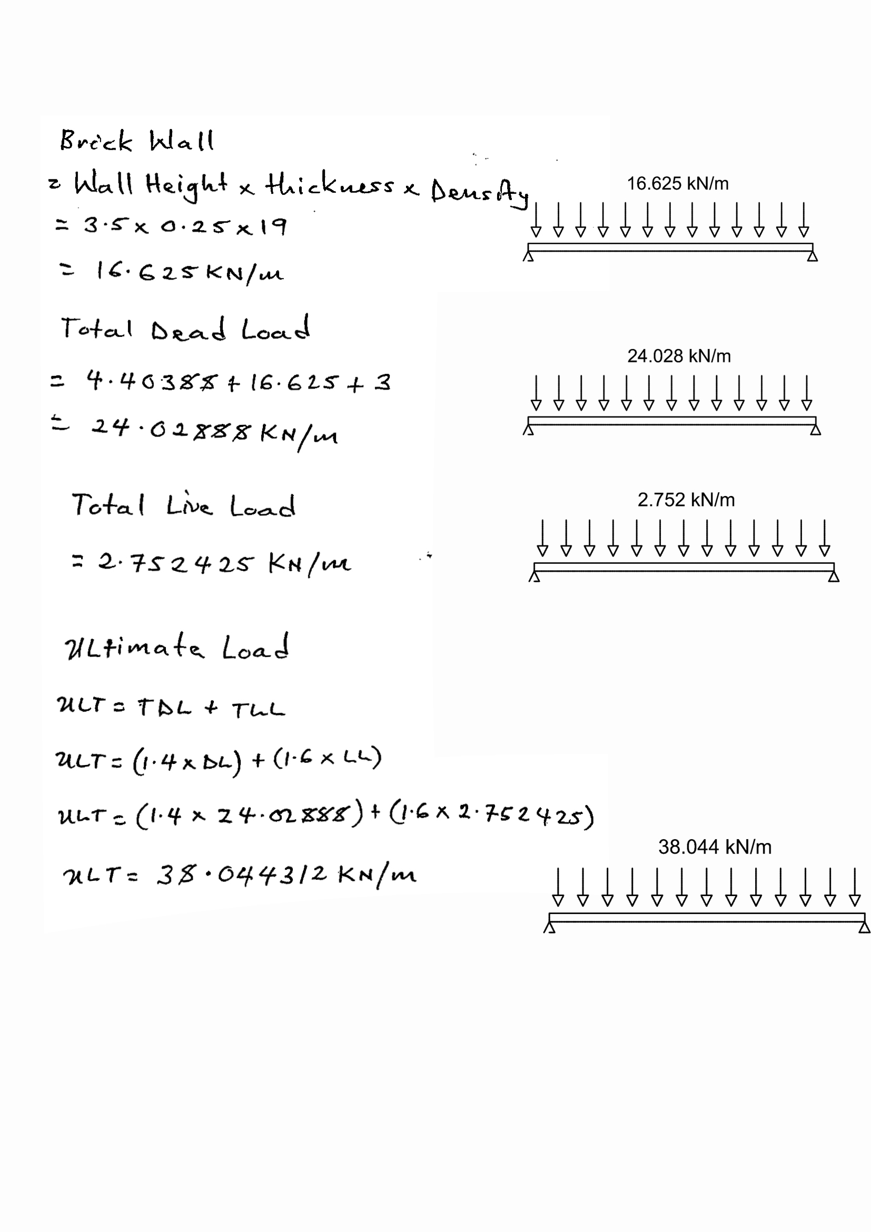

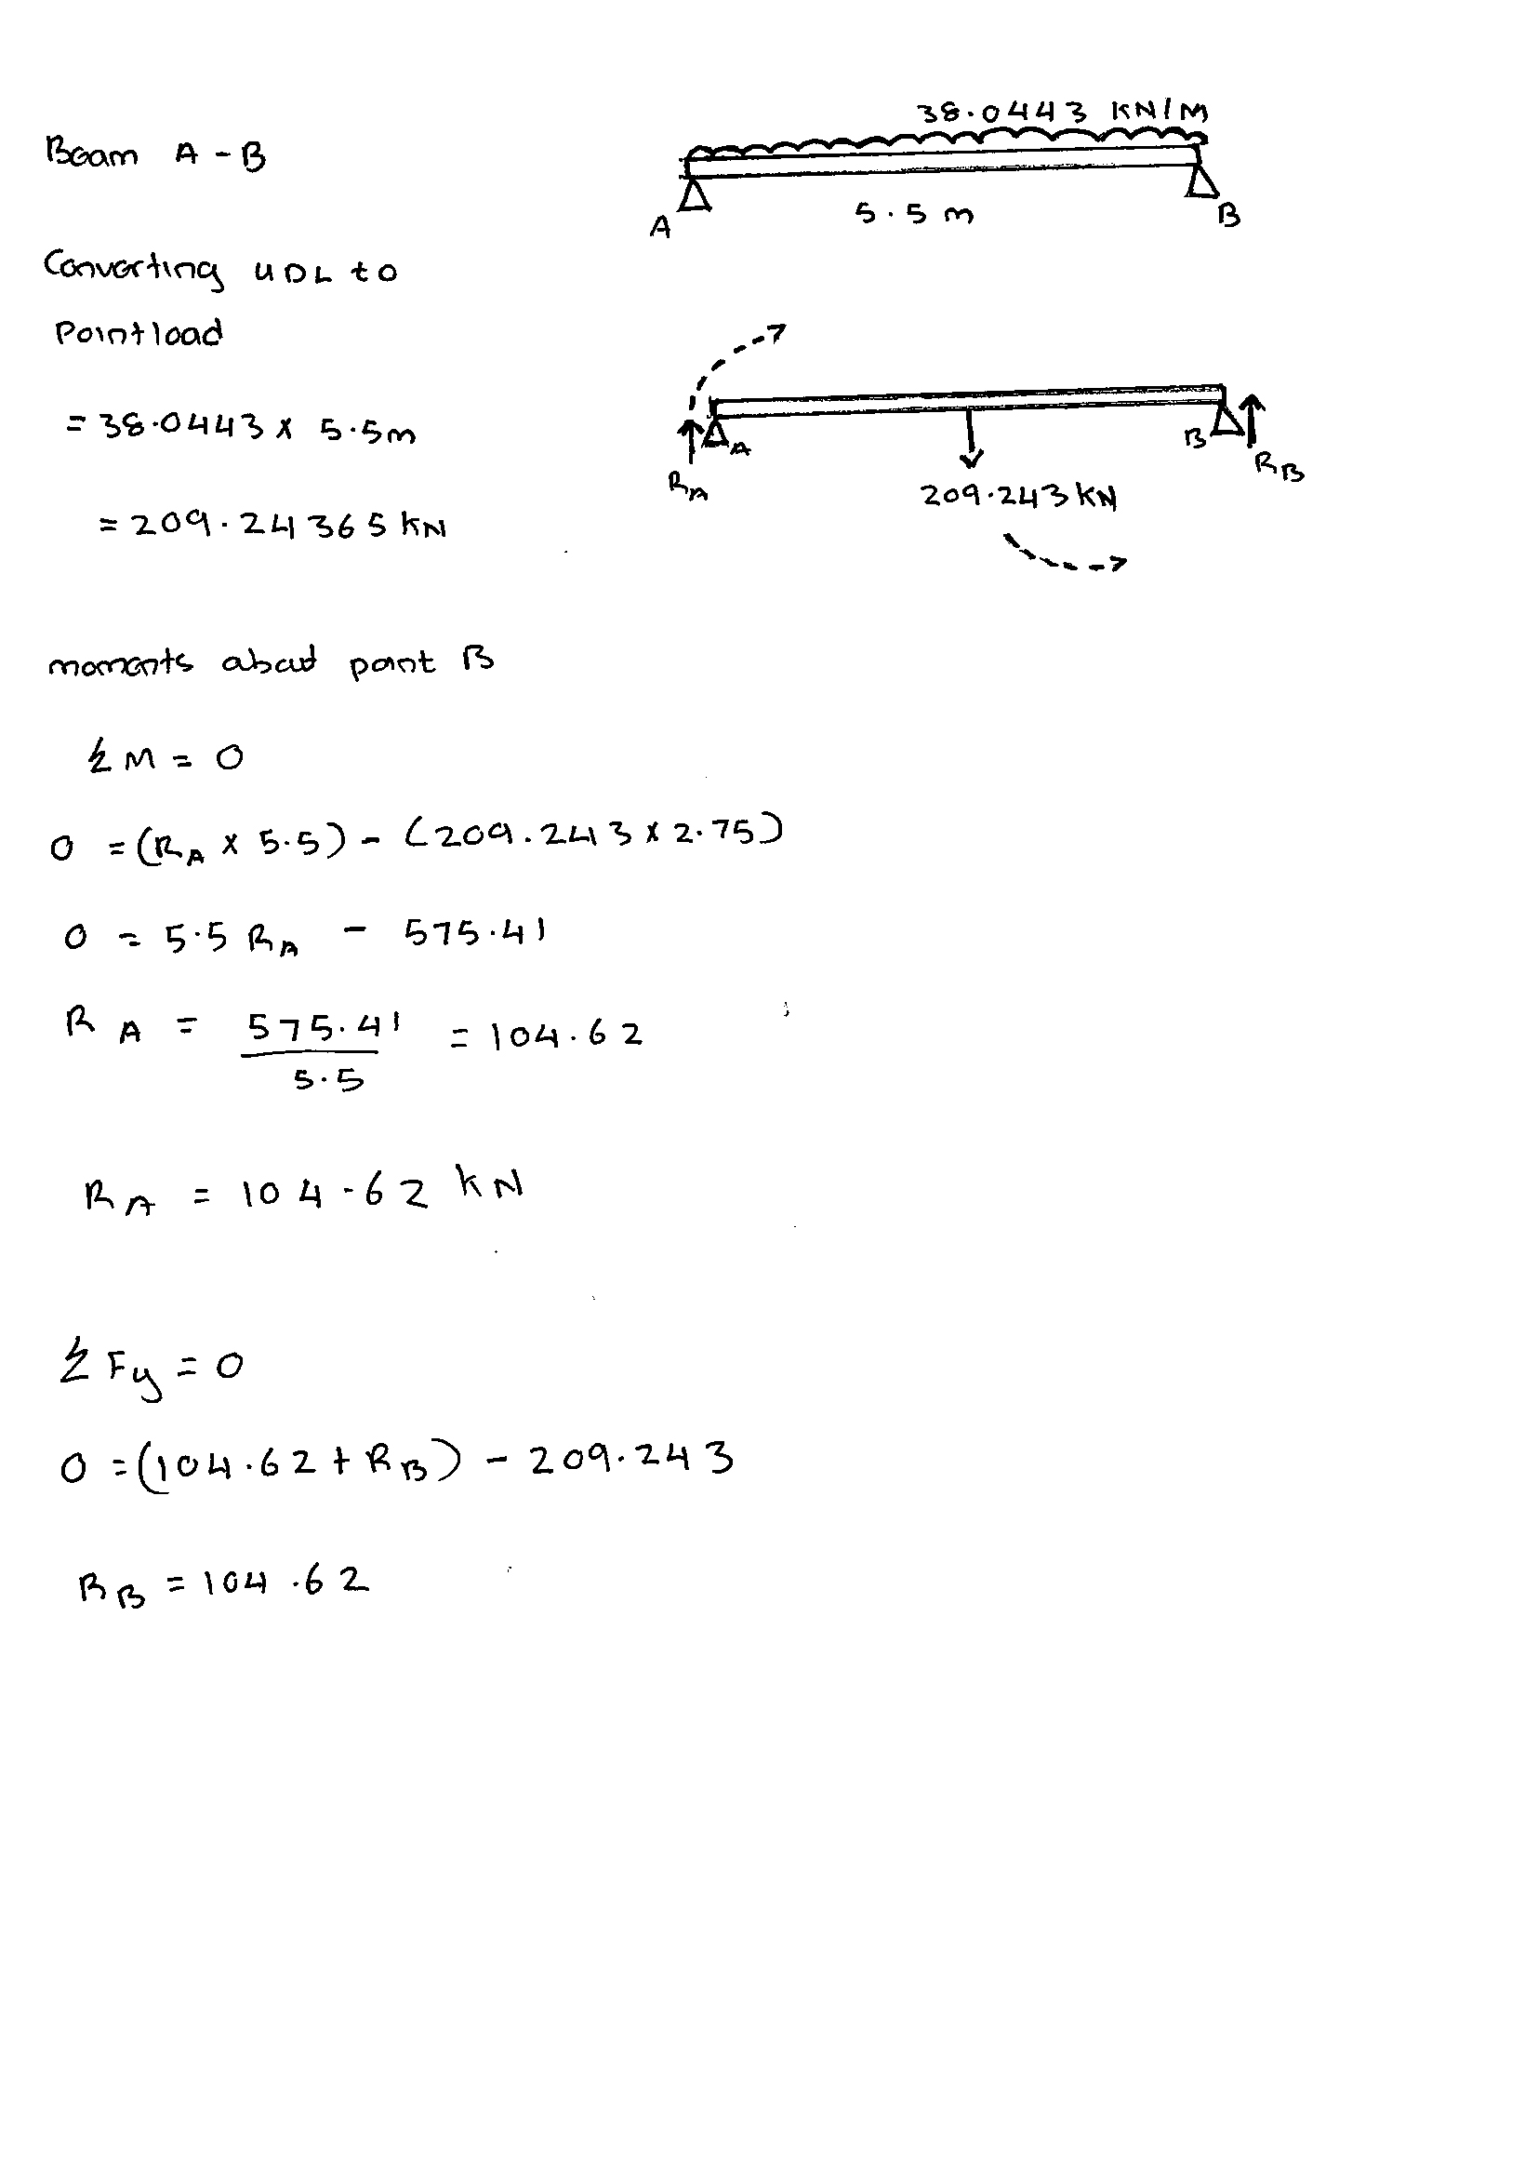REACTION FORCES

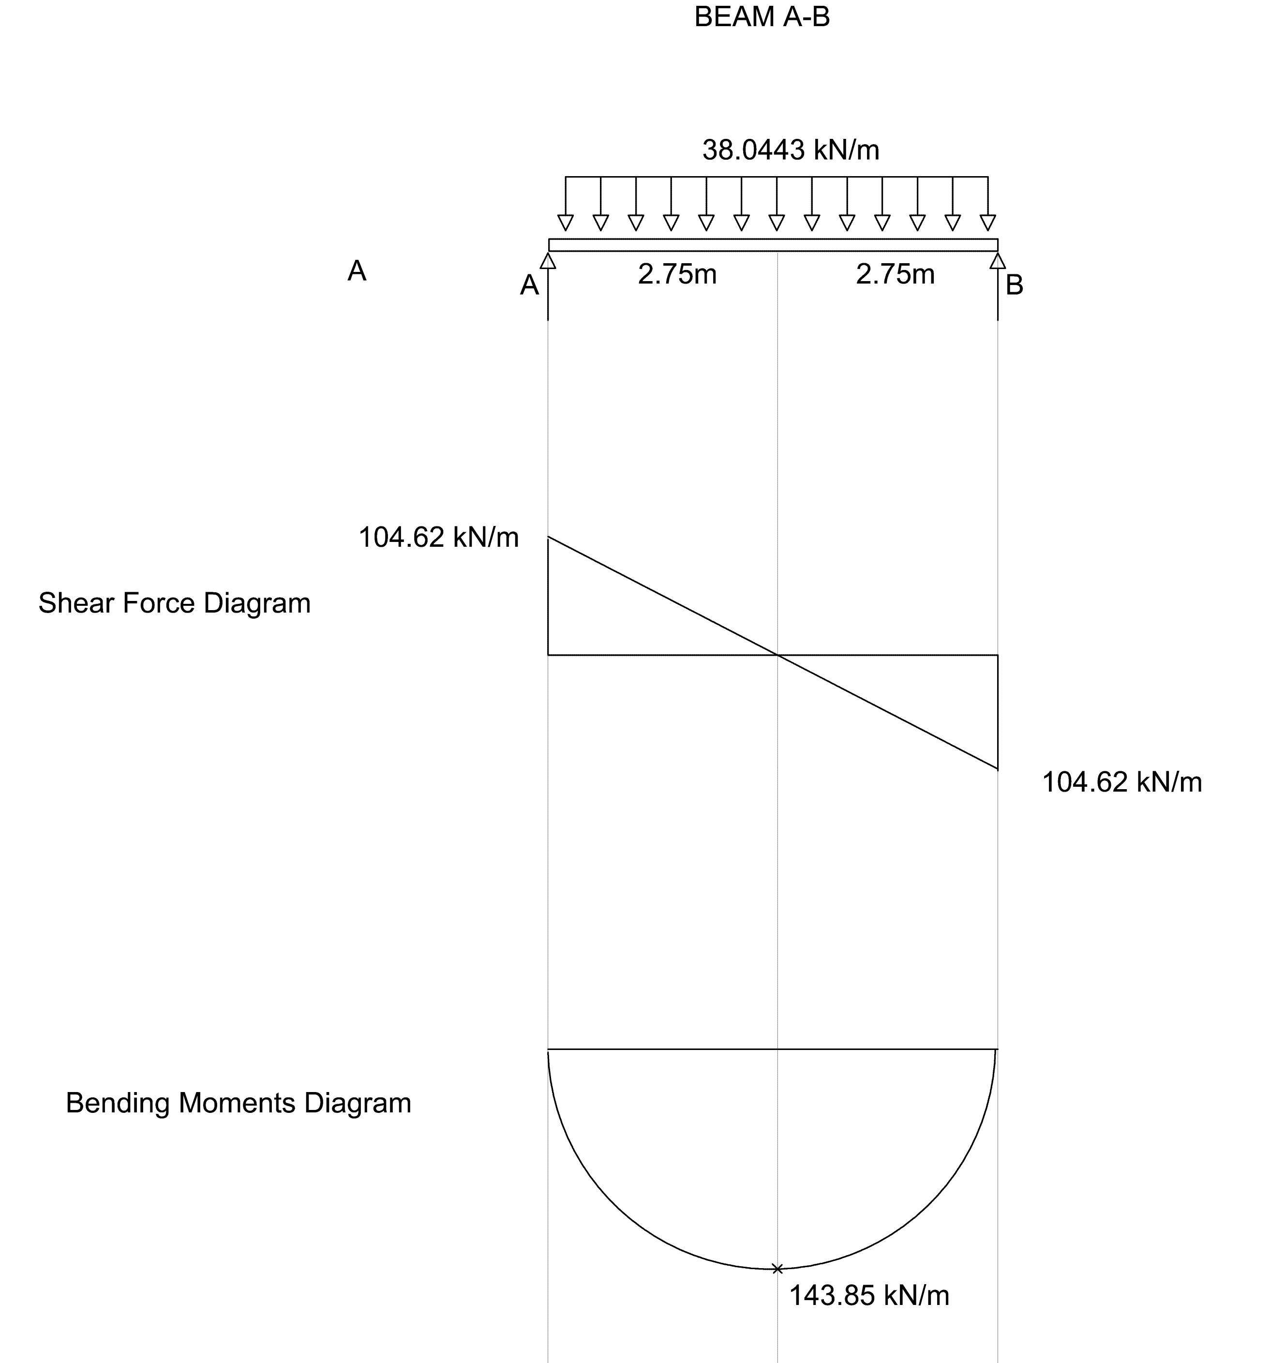SHEAR FORCE AND B

COLUMN ANALYSIS CALCULATION – TRIBUTARY AREA METHOD
LOAD DISTRIBUTION
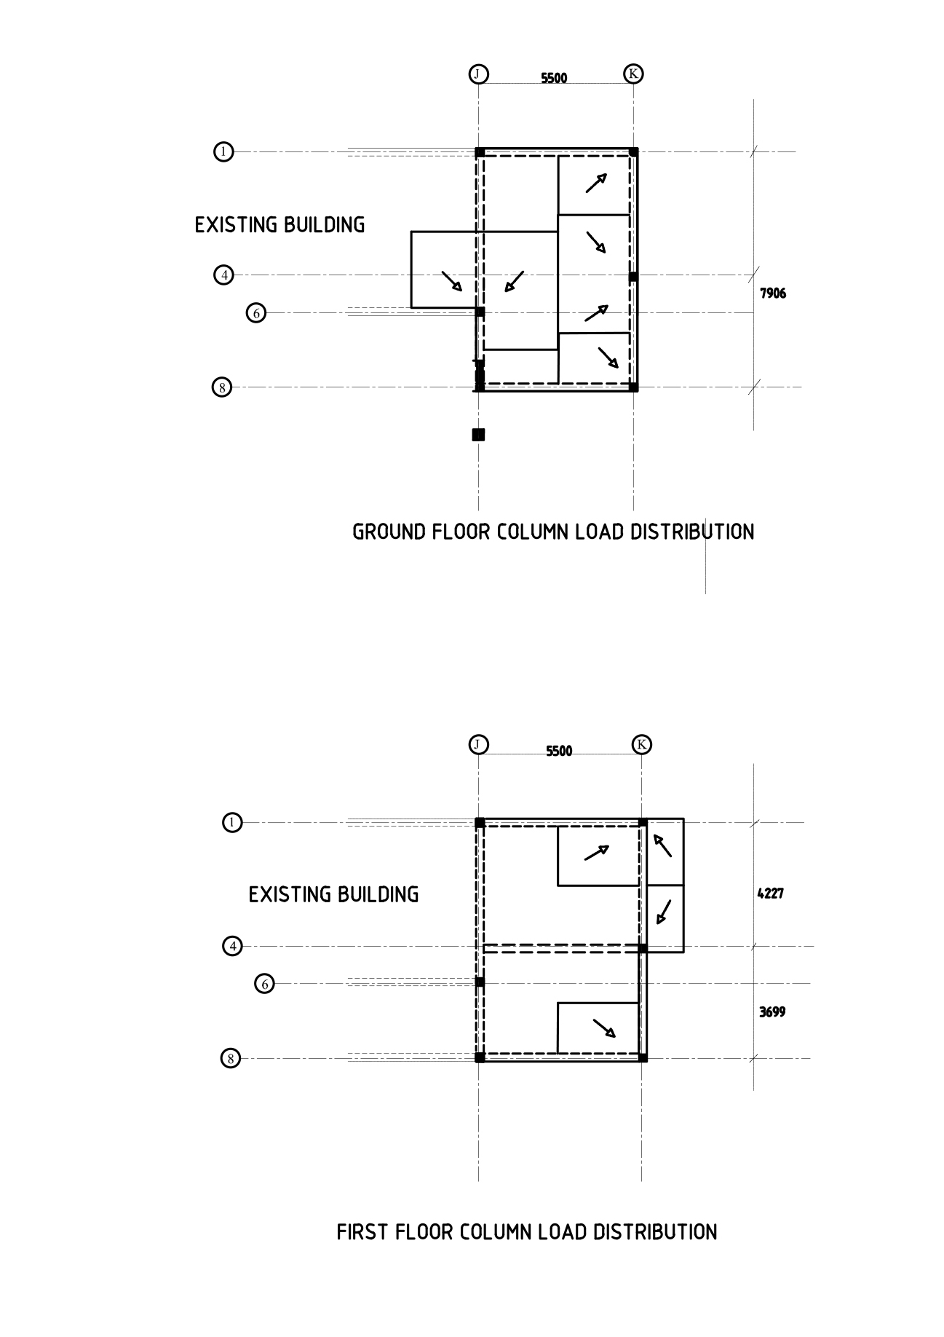

COLUMN J-6
1st floor
Areas
Living room= 2.21m x 2.59m = 5.7239m²
Tv room= (2.59 + 1.23) x 2.75 =10.505m³
Slab
Living room
Dead load
= slab self-weight x Area
=2.4KN/m² x 5.7239m² = 13.73kN
Live load
=2KN/m² x 5.7239m² = 11.44kN

Tv room
Dead load
=slab self-weight x Area
= 2.4kN/m² x 10.505m² = 25.21kN
Live load
1.5KN/m² x 0.505m² =15.75 kN
Beams
Beam 6/ I-J (self-weight)
=0.25m x 0.5m x24kN/m³ x 2.59 = 7.77kN
Beam J/ 1-6 (self-weight)
=0.25m x 0.5m x24kN/m³ x 5.85m = 17.55kN
Beam J/ 6-8 (self-weight)
=0.25m x 0.5m x24kN/m³ x 2.49 m = 7.47kN
Brick wall
Wall 6/ I-J
=3.5m x 0.25m x 19kN/m³ x 2.59m= 43.05kN
Wall J/ 1-6
=3.5m x 0.25m x 19kN/m³ x 5.85m= 97.25kN
Wall J/ 6-8
=3.5m x 0.25m x 19kN/m³ x 2.49m= 41.39kN
Total column load
=41.39+97.25+43.05+7.47+17.55+7.77+15.75+25.21+11.44+13.73
= 280.61kN

COLUMN K-1
Roof level
Area= 2.75m x 3.95m
=10.862m²
Live load from roof
=10.862m² x 0.5kN/m² = 5.431kN
Dead load from roof
=10.862m² x 1kN/m² = 10.862kN
Beam K/ 1-8 (self-weight)
==0.25m x 0.5m x24kN/m³ x 3.95= 11.85kN
Beam 8/ J-K (self-weight)
=0.25m x 0.5m x24kN/m³ x 2.75 = 8.25kN

Total column load from roof level = 36.393kN

1st floor
Area = 2.75m x 2.176m = 5.984m²
Slab
Live load = 2kN/m² x 5.984m² = 11.968kN
Dead load= slab self-weight x Area
=2.4kN/m2 x 5.984 = 14.36kN
Beams
Beam 1/ J-K (self-weight)
=0.25m x 0.5m x24kN/m³ x 2.75 = 8.25kN
Beam K/ 1-4 (self-weight)
=0.25m x 0.5m x24kN/m³ x 2.176m = 6.528kN

Brick wall
Wall 1/ J-K
=3.5m x 0.25m x 19kN/m³ x 2.75m= 45.71kN
Wall K/ 1-4
=3.5m x 0.25m x 19kN/m³ x 2.176m= 36.176kN

Total column load from 1st floor = 122.992kN

Ground floor
Area= 2.75m x 3.95m = 10.862m²
Slab
Live load = 1.5kN/m² x 10.862m² = 16.293kN
Dead load = slab self-weight x Area
=2.4kN/m² x 10.862m² = 26.068kN
Beams
Beam K/ 1-8 (self-weight)
=0.25m x 0.5m x24kN/m³ x 3.95m = 11.85kN
Beam 1/ J-K (self-weight)
=0.25m x 0.5m x24kN/m³ x 2.75 m = 8.25kN
Brick wall
Wall K/1-8
=3.5m x 0.25m x 19kN/m³ x 3.95m= 65.66kN
Wall 1/J-K
=3.5m x 0.25m x 19kN/m³ x 2.75m= 45.71kN
Total load on column from ground level=174.43kN

Total load on column K-1
=174.43+122.992+36.393 = 333.816kN

COLUMN K-4

1st floor level
Areas
Balcony = 2.17m x 0.598m =1.297m²
Workout room = 2.75m x 2.17m = 5.967m²
Study rom = 2.75m x 1.897m = 5.216 m²
Slab
-Balcony
Dead load= self-weight x Area
=2.4kN/m² x 1.297m² =14.36kN
Live load = 1.5kN/m² x 1.297m² =1.935kN
-workout room
Dead load = self-weight x Area
=2.4kN/m² x 5.967m² =14.32kN
Live load = 2kN/m2 x 5.967m² =11.934kN
-Study room
Dead load = self-weight x Area
=2.4kN/m² x 1.897m² =4.55kN
Live load= 1.5kN/m2 x 1.897m² =2.845kN

Beams
Beam 4/ J-K (self-weight)
=0.25m x 0.5m x24kN/m³ x 2.75m = 8.25kN
Beam K/ 4-8 (self-weight)
=0.25m x 0.5m x24kN/m³ x 1.897m = 5.691kN
Beam K/ 6-1 (self-weight)
=0.25m x 0.5m x24kN/m³ x 2.176m = 6.528kN

Brick wall
Wall 4/J-K
=3.5m x 0.25m x 19kN/m³ x 2.75m= 45.71kN
Wall K/4-8
=3.5m x 0.25m x 19kN/m³ x 1.897m= 31.53kN

Total load on column = 36.176+31.53+45.71+6.528+5.691+8.25+2.845+4.55+11.934+14.32+1.935+14.36= 183.829kN

COLUMN K-8

Roof level
Area = 2.75m x 3.95 m =10.862m²
Live load from roof
=10.862m² x 0.5kN/m² = 5.431kN
Dead load from roof
=10.862m² x 1kN/m² = 10.862kN
Beam K/ 1-8 (self-weight)
==0.25m x 0.5m x24kN/m³ x 3.95= 11.85kN
Beam 8/ J-K (self-weight)
=0.25m x 0.5m x24kN/m³ x 2.75 = 8.25kN

Total column load from roof level = 36.393kN

1st floor
Area= 2.75m x 1.897m = 5.216m²
Slab
Live load= 1.5kN/m² x 5.216m² = 7.824kN
Dead load= slab self-weight x Area
=2.4kN/m² x 5.216m² = 12.518kN
Beams
Beam 8/ J-K (self-weight)
=0.25m x 0.5m x24kN/m³ x 2.75 = 8.25kN
Beam K/ 4-8 (self-weight)
=0.25m x 0.5m x24kN/m³ x 1.897 = 5.691kN

Brick wall
Wall 8/J-K
=3.5m x 0.25m x 19kN/m³ x 2.75m= 45.71kN
Wall K/4-8
=3.5m x 0.25m x 19kN/m³ x 1.897m= 31.53kN

Total load on column from 1st floor =111.53kN

Ground floor
Area = 2.75m x 3.95m =10.862m²
Slab
Live load = 1.5kN/m² x 10.862m² = 16.293kN
Dead load = slab self-weight x Area
=2.4kN/m² x 10.862m² = 26.068kN
Beams
Beam K/ 1-8 (self-weight)
=0.25m x 0.5m x24kN/m³ x 3.95m = 11.85kN
Beam 8/ J-K (self-weight)
=0.25m x 0.5m x24kN/m³ x 2.75 m = 8.25kN
Brick wall
Wall K/1-8
=3.5m x 0.25m x 19kN/m³ x 3.95m= 65.66kN
Wall 8/J-K
=3.5m x 0.25m x 19kN/m³ x 2.75m= 45.71kN

Load on column from ground floor = 173.84kN

Total load on column K-8 =
173.84+111.53+36.393 = 321.763kN

